Wildlife GPS Tracking Collar

Detailed Design Document

**Prepared by:**

Ben Lawson

Ben Shewan

Collin Halamka

Collin Maker

Garrett Harris

**Submitted to:**

Dr. Paul Keenlance

Dr. Jeffrey Ward

Dr. Bruce Dunne

EGR 485/486 Senior Project

Spring/Summer Term 2019

**March 2019**

**[This page intentionally left blank]**

# Table of Contents

**Table of Contents** **2**

**1 Executive Summary** **4**

**2 Introduction and Design Background** **5**

**3 Requirements and Functional Specifications** **6**

3.1 Medium Collar 6

3.2 Small Collar 12

**4 System Architecture** **17**

4.1 System Logical Design 17

4.2 Microcontroller - STM32L0 18

4.3 GPS Module - NEO-M8N 18

4.4 VHF Transmitter 19

4.5 Battery - Tadiran TL-5902/3 20

4.6 XBee - XB9X-DMUS-001 21

4.7 Software 22

4.8 Device Software 22

4.8.1 Main Collar Software Logic 24

4.8.2 Programming Device Routine Logic 25

4.8.3 GPS Routine Logic 26

4.8.4 VHF Routine Logic 27

4.8.5 XBee Routine Logic 28

**5 Hardware Implementation** **29**

5.1 Power Source Selection 29

5.2 Microcontroller 31

5.3 GPS 32

5.4 XBee 34

5.5 VHF Beacon 35

5.6 Printed Circuit Board 36

**6 Packaging Design - Medium Collar** **43**

6.1 Enclosure Design 43

6.1.1 Collar Strap Connection 51

6.1.2 Enclosure Sealing and Gasket 52

6.2 Collar & Fasteners 54

6.3 Packaging Component Validation 56

6.4 System Validation 57

6.5 Mechanical Fabrication and Assembly Overview 58

**7 Packaging Design - Small Collar** **59**

7.1 Collar Design & Waterproofing 59

**8 Deliverables** **61**

**9 Schedule and BOM/Expense Report** **62**

9.1 Schedule 62

9.2 BOM/Expense Report 62

**Appendix A -- Electrical Schematics** **69**

**Appendix B -- Electrical Simulations** **75**

**Appendix C -- Mechanical Drawings (Also see attached PDF)** **78**

**Appendix D -- Verification Hand Calculations** **85**

# 

# 1 Executive Summary

The purpose of this project was to further develop previous senior projects’ wildlife tracking collars. The collars are for use with wildlife, by the GVSU Biology Department, to collect GPS tracking data on wild animals and further their research. The new collars are to be a field-deployable design for both the medium and small wildlife GPS tracking collars. The goal behind the project is to improve all aspects of the previous collars so that Grand Valley State University’s Biology Department can deploy the developed collars into the field and have the collar design be in a state that allows for ease of manufacture for mass distribution in the future. Complete and optimally operating devices are the scope of the project to ensure the Biology Department can conduct research on animals ranging from Martens to Bobcats as the collar sizes range from smaller to larger.

# 

# 2 Introduction and Design Background

The GVSU School of Biology has requested the design and development of previous years’ Wildlife GPS tracking collar projects. The past two years (2017 and 2018) the engineering program has developed prototype wildlife collars for the School of Biology that targeted the fit and functionality of tracking animals in the wild. The 2017 collar project team used a GPS module to track an animal’s location, a VHF transmitter to locate the animal, and an Xbee-based communication protocol that allowed the user to download the data once within a roughly 100 meter radius. The 2018 collar used the same GPS functionality with much heavier Iridium satellite equipment for remote download of the tracking data. Although the previous collars were satisfactory prototypes, they were not robust enough to be deployed in the field. The purpose of the current project is to further develop the 2017 GPS focused collar to a field-ready state utilizing a new VHF transmitter. Along with making the medium sized collar field-ready, a second smaller collar is also to be developed. The smaller collar is to be a simplified design, based on the medium collar, for collecting gps data to be used on smaller animals in the wild.

The GPS Wildlife collars will have similar functionality to that of the 2017 project group’s with some improvements made to the design. The medium collar is to include the capabilities of GPS logging, VHF tracking, and wireless data transmission with Xbee-based communication protocol. Advancements in the design are focused on: reducing the size of the battery and GPS housings along with their enclosed circuitry while maintaining durability, reducing the weight of the collar assembly, improving the comfort of the collar on the animal (ie. no loose wires or protruding components), all while maintaining GPS logging, tracking, wireless communication, and battery life capabilities similar to that of the 2017 group. The device should include these improvements while being able to survive the wilderness. The small collar will only include GPS tracking and the design will prioritize size and weight over other extra functionality.

Currently there are GPS tracking collars available on the market, but they are overpriced and do not always perform as expected once deployed in the field. Another goal of this project is to develop the larger and smaller collars at a fraction of the cost of the commercially available collars. To achieve this goal reproducibility of both collars was considered. Detailed documentation will be provided for a technician to reproduce the collars. Any components that are not able to be produced using the engineering department’s capabilities can be outsourced to vendors to simplify production on a larger scale in the future.

# 3 Requirements and Functional Specifications

## 3.1 Medium Collar

Below are the specifications for the medium sized wildlife tracking collar. Phase 1 specifications (noted as **3.1.X.X.X)** will define the minimum required product specifications upon the completion of the project. Deviations from, or omissions of these requirements must be discussed and approved in writing by the project faculty advisor and sponsors. Phase 2 specifications (noted as **3A.1.X.X.X)** may be implemented in the final product(s) as time and resources allow. These specifications represent deliverables that would increase the value of the project, but are not required as final deliverables. The numbering system per specification department is as follows: 3.1.0.X - Functional Specifications, 3.1.1.X - Mechanical Specification, 3.1.2.X - Electrical Specification, 3.1.3.X - Performance Specification, 3.1.4.X - Miscellaneous Specification, 3.1.5.X - User Interface Specification.

**Phase 1 Specifications:**

**Functional Specifications:**

**3.1.0.1** The collar shall include a Global Positioning System (GPS) module for position acquisition.

**3.1.0.2** The collar shall include an Xbee module for remote data download.

**3.1.0.3** The collar shall include a Very High Frequency (VHF) beacon with customizable active hours for locating the collar. This item is provided by the sponsor from a masters students thesis.

**3.1.0.4** The collar shall include a shop accessible port which will allow for data download and configuration of the collar.

**3.1.0.5** The collar shall be fully functioning and field deployable for use on an animal.

**Mechanical Specifications:**

**3.1.1.1** The total mass of the collar shall not exceed 125 grams. This includes collar strapping, fasteners, battery, enclosure(s), and electronic components.

**3.1.1.2** The enclosure(s) shall maintain structural integrity and functionality while enduring a simulated bite with a total load of 400 lbs, distributed over the whole jaw and enclosure.

**3.1.1.2.1** The simulation will be conducted by modeling the bite as a force distributed over 8 points. The points will be distributed on two opposing sides of the enclosure in a pattern similar to the teeth of a predator. The maximum stress must be below the yield strength of the enclosure material.

**3.1.1.3** The collar strap shall have a tensile strength of at least 7.5 MPa.

**3.1.1.4** Wiring passing outside enclosures will be shielded to provide strain relief and wear resistance. The wires connecting the housings will not be exposed to the environment.

**3.1.1.4.1** External wire shielding shall have a minimum tensile strength of at least 7.5 MPa at the connection point for each housing.

**3.1.1.5** Collar enclosures will not exceed a volume of the following:

**~~3.1.1.5.1~~** ~~Lower Housing (External L x W x H): 68mm x 38mm x 34mm~~

**~~3.1.1.5.2~~** ~~Upper Housing (External L x W x H): 50mm x 30mm x 15mm~~

**3.1.1.5.3** Single Housing Volume of 110,356 mm (Example External LxWxH): 69mm x 44mm x 35mm (updated specification verbal acceptance by Dr. Keenlance)

**3.1.1.6** Color shall be muted earth tones. Acceptable colors based on past iteration of this project include, but are not limited to: black, brown, and green.

**3.1.1.7** Battery shall be shop replaceable.

**3.1.1.8** Collar circumference shall be adjustable between 210 mm and 300 mm.

**Electrical Specifications:**

**3.1.2.1** Battery life of the collar should be 151 days (at optimal operating conditions and with default operating parameters). The default operating parameters are found in Table 1.

**3.1.2.1.1** A battery life estimation tool will be provided as a deliverable. The tool will calculate the battery life of the collar based on variable values entered by the user. The tool entry variables will be: GPS fixes per day, VHF beacon hours per days, and VHF beacon days per week. These variables with their limits are shown in Table 1.

**Table 1:** Operating Parameters for Medium Device

|  |  |  |  |
| --- | --- | --- | --- |
| **Operating Parameter** | **Minimum Value** | **Default Operation Value** | **Maximum Value** |
| GPS Fixes Per Day (Fixes/Day) | 0 | 6 | 144 |
| Active VHF Beacon Window (Hrs/Day) | 0 | 4 | 24 |
| Active VHF Beacon Days per Week (Days/Week) | 0 | 1 | 7 |
| Environmental Temperature (°C) | -10 | 25 | 30 |

**Performance Specifications:**

**3.1.3.2** There shall be a user-programmable amount of GPS fixes per 24 hour period (default configuration is 6 fixes per day).

**3.1.3.2.1** GPS fixes per day shall be programmable by the user. This programmed quantity of fixes would result in a recalculated battery life. (See Table 1)

**3.1.3.2.2** The GPS receiver will be accurate to within 15 meters when operating unobstructed in an open field.

**3.1.3.3** The custom in-house developed VHF Beacon provided by the sponsor shall operate within provided specs.

**3.1.3.3.1** The VHF Beacon shall have a user programmable time window and frequency. Typical is 4 hours a day, 1 day a week. Different time windows and frequencies will recalculate a new battery life (see Table 1 above).

**3.1.3.4** Xbee communication range shall be 125 meters unobstructed in an open field.

**3.1.3.4.1** Xbee communication will be completed using the dongle developed by the 2017 Animal Collar team. A new dongle will not be developed.

**3.1.3.4.2** Xbee communication data rate and format will be compatible with the 2017 project dongle.

**3.1.3.4.3** Data transmitted will include recorded GPS locations with corresponding date and time information.

**3.1.3.4.4** The collar shall support a mode in which only data recorded since the last confirmed wireless transmission is sent to the receiver. In this mode, the receiver shall acknowledge the number of points received. If the number received matches the number sent, only future location fixes will be sent over the wireless interface. The full data log will be kept in memory for redundancy if memory is not full.

**3.1.3.5** The device will have a magnetic switch on the housing that will hold the device in the OFF state until the magnet is removed.

**Environmental Specifications:**

**3.1.4.1** The enclosure(s) for electronic components shall be dust protected (IP5X). The enclosure(s) will be, at a minimum, water resistant, withstanding water jets in all directions with a volume rate of 10 liters per minute (IPX4).

**3.1.4.2** The tracking collar will be fully functional at standard room temperature (25°C) with the calculated battery life of 151 days (using configuration values shown in Table 1).

**3.1.4.2.1** The tracking collar will be operational for the average climate of northern Michigan (ie in the range of -10°C to 30°C). Battery life may be derated when operating outside of standard operating temperature.

**User Interface Specifications:**

**3.1.5.1** The user interface will allow the user to configure the device via a wired USB dongle from the default setup.

**3.1.5.1.1** The GPS fix rate will be configurable from 2 to 144 (6/hour) a day (see Table 1 above).

**3.1.5.1.2** The VHF Beacon will have user programmable hours per day and days per week (see Table 1 above).

**3.1.5.1.3** There will be a configuration manual, for a shop technician to follow, that will provide a sequence of operations to configure the GPS module and VHF Beacon.

**3.1.5.2** The user interface will be compatible with Windows 10 operating system.

**3.1.5.3** The collar shall provide a physical connection that is shop accessible for data acquisition and programming.

**3.1.5.4** There will be manuals provided. One technical manual for technicians with technical understanding. One user manual for basic operation of the collar.

**Phase 2 Specifications:**

Phase 2 specifications may be implemented in the final product(s) as time and resources allow. These specifications represent deliverables that would increase the value of the project, but are not required as final deliverables.

**3A.1.1.1** A water-tight enclosure may be implemented. The enclosure will withstand immersion in water at a depth of 1m for up to 30 minutes and will replace the IPX4 specification with a IPX7 requirement.

**3A.1.1.2** The total mass of the enclosure may be reduced to less than 125 grams.

**3A.1.1.3** The enclosure’s total volume may be reduced by more than 20%.

**3A.1.1.4** Battery may be field replaceable.

**3A.1.2.1** Battery life of the collar may exceed 151 days with default operating parameters.

**3A.1.3.1** Xbee communication range may exceed 125 meters.

**3A.1.3.2** The cost to reproduce the medium collar should be less than $300.

**3A.1.5.1** The configuration tool will allow the user to configure the device via XBee.

## 3.2 Small Collar

Below are the specifications for the small sized wildlife tracking collar. Phase 1 specifications (noted as **3.2.X.X.X)** will define the minimum required product specifications upon the completion of the project. Deviations from, or omissions of these requirements must be discussed and approved in writing by the project faculty advisor and sponsors. Phase 2 specifications (noted as **3A.2.X.X.X)** may be implemented in the final product(s) as time and resources allow. These specifications represent deliverables that would increase the value of the project, but are not required as final deliverables. The numbering system per specification department is as follows: 3.2.0.X - Functional Specifications, 3.2.1.X - Mechanical Specification, 3.2.2.X - Electrical Specification, 3.2.3.X - Performance Specification, 3.2.4.X - Miscellaneous Specification, 3.2.5.X - User Interface Specification.

**Phase 1 Specifications:**

**Functional Specifications:**

**3.2.0.1** The collar shall include a Global Positioning System (GPS) module for position acquisition.

**3.2.0.2** The collar shall include a shop accessible port which will allow for data download and configuration of the collar.

**3.2.0.3** The collar shall be fully functioning and field deployable for use on an animal.

**Mechanical Specifications:**

**3.2.1.1** The total mass of the collar shall not exceed 35 grams. This includes collar strapping, fasteners, battery, enclosure(s), and electronic components.

**3.2.1.2** The collar strap shall have a tensile strength of at least 7.5 MPa.

**3.2.1.3** Wiring passing outside enclosures will be shielded to provide strain relief and wear resistance. The wires connecting the housings will not be exposed to the environment.

**3.2.1.3.1** External wire shielding shall have a minimum tensile strength of at least 7.5 MPa at the connection point for each housing.

**3.2.1.4** Collar Enclosure will be as small as the components allow with target external dimensions of:

**3.2.1.4.1** Housing (External L x W x H): 40mm x 25mm x 25mm

**3.2.1.5** Color shall be muted earth tones. Acceptable colors based on past iteration of this project include, but are not limited to: black, brown, and green.

**3.2.1.6** Battery shall be shop replaceable.

**Electrical Specifications:**

**3.2.2.1** Battery life of the collar should be 21 days with default operating parameters. The small collar’s default operating parameters can be found in Table 2.

**3.2.2.1.1** A battery life estimation tool will be provided as a deliverable. The tool will calculate the battery life of the collar based on variable values entered by the user. The tool entry variables will be: GPS fixes per day, VHF beacon hours per days, and VHF beacon days per week. These variables with their limits are shown in Table 2.

**Table 2:** Operating Parameters for Small Device

|  |  |  |  |
| --- | --- | --- | --- |
| **Operating Parameter** | **Minimum Value** | **Default Operation Value** | **Maximum Value** |
| GPS Fixes Per Day (Fixes/Day) | 0 | 3 | 144 |
| Active VHF Beacon Window (Hrs/Day) | 0 | 4 | 24 |
| Active VHF Beacon Days per Week (Days/Week) | 0 | 1 | 7 |
| Environmental Temperature (°C) | -10 | 25 | 30 |

**Performance Specifications:**

**3.2.3.1** There shall be a user-programmable amount of GPS fixes per 24 hour period (Default configuration is 3 fixes per day).

**3.2.3.1.1** GPS fixes per day shall be programmable by the user. This programmed quantity of fixes would result in a recalculated battery life. (See Table 2)

**3.2.3.1.2** The GPS receiver will be accurate to within 15 meters when operating unobstructed in an open field.

**3.2.3.2** The custom in-house developed VHF Beacon provided by the sponsor shall operate within provided specs.

**3.2.3.2.1** The VHF Beacon shall have a user programmable time window and frequency. Typical is 4 hours a day, 1 day a week. Different time windows and frequencies will recalculate a new battery life (see Table 2 above).

**3.2.3.3** The device will have a magnetic switch on the housing that will hold the device in the OFF position until the magnet removed.

**Environmental Specifications:**

**3.2.4.1** ~~The enclosure(s) for electronic components shall be dust protected (IP5X). The enclosure(s) will be, at a minimum, water resistant, withstanding water jets in all directions with a volume rate of 10 liters per minute (IPX4).~~

Water and dust resistance not a priority. Electrical components will be potted in epoxy, and the battery enclosed with those components in shrink wrap tubing.

**3.2.4.2** The tracking collar will be fully functional at standard room temperature (25°C) with the calculated battery life of 21 days.

**3.2.4.2.1** The tracking collar will be operational for the average climate of northern Michigan (ie in the range of -10°C to 30°C). Battery life may be derated when operating outside of standard operating temperature.

**User Interface Specifications:**

**3.2.5.1** The user interface will allow the user to configure the device via a wired USB dongle from the default setup.

**3.2.5.1.1** The GPS fix rate will be configurable from 2 to 144 (6/hour) a day (see Table 1 above).

**3.2.5.2** The user interface will be compatible with Windows 10 operating system.

**3.2.5.3** The collar shall provide a physical connection that is shop accessible for data acquisition and programming.

**3.2.5.4** There will be manuals provided. One technical manual for technicians with technical understanding. One user manual for basic operation of the collar.

**Phase 2 Specifications:**

Phase 2 specifications may be implemented in the final product(s) as time and resources allow. These specifications represent deliverables that would increase the value of the project, but are not required as final deliverables.

**3A.2.1.1** A water-tight enclosure may be implemented. The enclosure will withstand immersion in water at a depth of 1m for 30 minutes and will replace the IPX4 requirement with a IPX7 requirement.

**3A.2.1.2** The total mass of the enclosure may be reduced to less than 35 grams.

**3A.2.1.3** Battery may be field replaceable.

**3A.2.2.1** Battery life of the collar may last more than 21 days.

**3A.2.3.1** Xbee communication may be a function included in the small device.

**3A.2.3.1.1** Xbee communication data rate and format will be compatible with the 2017 project dongle.

**3A.2.3.2** The collar may include a Very High Frequency (VHF) beacon with customizable active hours for locating the collar. This item is provided by the sponsor from a previous year’s senior project.

**3A.2.3.2.1** The VHF Beacon may have user programmable hours per day and days per week (see Table 2 above).

# 4 System Architecture

## 

## 4.1 System Logical Design

The system block diagram is shown below in Figure 1. The collar’s system is powered by its connection to the computer using the USB Comm harness when the system is being programmed. When the system is deployed, the power selection circuit will begin to run the system off of its battery power. The microcontroller will control the various peripherals in the system, directly activating and deactivating the devices on properly timed intervals selected by the user in the programming process. The system will have an ultra low power mode to preserve battery life in between when the device is programed and deployed in the field. The mode will be activated with a magnet sensor; full system operation will begin when the magnet is removed.

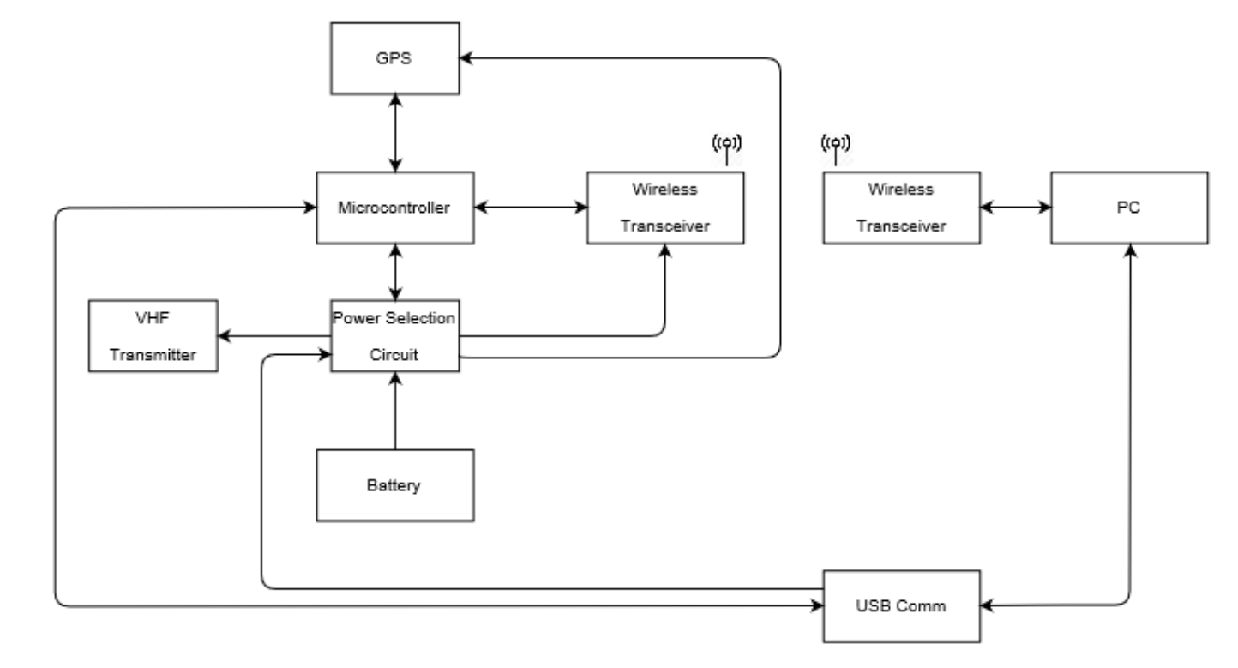

**Figure 1.** System Block Diagram

## 

## 

## 4.2 Microcontroller - STM32L0

The microcontroller of the system acts to tie all of the peripheral devices together. It will activate the other devices to coordinate the operation of the system based on the software instructions. Based on the ARM Cortex M0+, the STM32L071 microcontroller unit (MCU) appears in the design for both the small and medium animal tracking collar. This device was chosen for its small footprint, ultra low power features, acceptable number of serial and general purpose input output (GPIO) ports, ample internal storage, and onboard real time clock (RTC). The system will operate mostly in near shutdown sleep states that will respond only to interrupts from the RTC. This will schedule the other devices for their operation only at the programmed times to save on power during operation of the device. Additionally, it will act as an intermediary between the GPS device that will store the GPS fix data, and the XBee transceiver, that will communicate with the end user.

**Table 3:** STM32L0 Electrical Characteristics

|  |  |  |  |  |
| --- | --- | --- | --- | --- |
| Electrical Characteristic | Minimum | Maximum | Nominal | Units |
| Operating Voltage | 1.6 | 3.6 | - | V |
| Operating Temperature | -40 | 125 | 25 | ℃ |
| Current - Run (2 MHz PLL) | - | 290 | 245 | µA |
| Current - RTC Stop | - | 0.99 | 0.34 | µA |

## 4.3 GPS Module - NEO-M8N

Both the animal tracking collar as well as the small animal tracking collar will employ the u-blox NEO-M8N Global Navigation Satellite System (GNSS) module. This device will receive, interpret, and store the GPS fix data on intervals set in the programming phase of product deployment. This module was chosen based on its ease of integration and component features. The module sports an internal low noise amplifier (LNA) and surface acoustic wave (SAW) filter allowing for the passive patch antenna to be integrated with a smaller PCB footprint and less complexity. The battery backup feature of the board will sacrifice a small amount of current in order to run an accurate RTC internally. This RTC will feed data to the GPS module on startup that will allow for far faster acquisition times which will allow for lower power operation overall. Finally, the device has multiple communication modes allowing for flexibility in interfacing with it via the MCU. The relevant specifications for the module follow in Table 4 below.

**Table 4:** GPS Module Electrical Characteristics

|  |  |  |  |  |
| --- | --- | --- | --- | --- |
| Electrical Characteristic | Minimum | Maximum | Nominal | Units |
| Power Supply Voltage | 2.7 | 3.6 | - | V |
| Backup Voltage | 1.4 | 3.6 | - | V |
| Operating Temperature | -40 | 85 | - | ℃ |
| Acquisition Current | - | 67 | 32 | mA |
| Tracking Current | - | 67 | 12 | mA |
| Backup Current | - | - | 15 | µA |

## 4.4 VHF Transmitter

This VHF device will be set to be activated during a time window of the user’s choosing. When activated, it will emit a low duty cycle pulse that will allow the researcher to locate the device in the field. The VHF Transmitter used in the project will be of the same design as the Master’s Thesis by Brian Westra. The only modification to the circuit will be the removal of the magnetic switch, instead replaced by a power enable circuit in line with other modules. The specifications of the design follow in Table 5.

**Table 5:** VHF Electrical Characteristics

|  |  |  |  |  |
| --- | --- | --- | --- | --- |
| Electrical Characteristic | Minimum | Maximum | Nominal | Units |
| Operating Voltage | - | - | 3.3 | V |
| Current | - | - | 0.193 | mA |

## 4.5 Battery - Tadiran TL-5902/3

The medium animal tracking collar will be powered by a single Tadiran TL-5903, a non-rechargeable lithium thionyl chloride cell. The TL-5903 cell is rated at 2.4 Ah at 25 °C and will operate between -55 °C and 85 °C. The cell is 14.5 mm in diameter and 50.5 mm in length, having a mass of 18 grams. This cell fits within the size, weight and power requirements for the design.

The small animal tracking collar will utilize a Tadiran TLL-5902, 25.2 mm in length and 14.5 mm in diameter. The battery selection is subject to change based on form factor, circuit and weight considerations.

Initial power calculations (shown in Appendix D) indicate that under worst case conditions the medium collar would last approximately 310 days and the small collar would last approximately 300. Worst case conditions constitute maximum rated current draw for each IC component and the maximum rated GPS fix time. The calculations assume 6 GPS fixes per day and the medium collar having a VHF on time of 4 hours per week.

**Table 6:** TL-5903 Characteristics

|  |  |  |  |  |
| --- | --- | --- | --- | --- |
| Electrical Characteristic | Minimum | Maximum | Nominal | Units |
| Capacity | - | - | 2.4 | Ah |
| Rated Voltage | - | - | 3.6 | V |
| Continuous Current | - | 100 | - | mA |
| Operating Temperature | -55 | 85 | - | ℃ |
| Weight | - | - | 18 | g |

**Table 7:** TLL-5902 Characteristics

|  |  |  |  |  |
| --- | --- | --- | --- | --- |
| Electrical Characteristic | Minimum | Maximum | Nominal | Units |
| Capacity | - | - | 1.2 | Ah |
| Rated Voltage | - | - | 3.6 | V |
| Continuous Current | - | 35 | - | mA |
| Operating Temperature | -55 | 85 | - | ℃ |
| Weight | - | - | 9.6 | g |

## 4.6 XBee - XB9X-DMUS-001

The XB9X-DMUS module was selected both to comply with the existing USB dongle provided to the biology department by the 2017 design team, as well as because it offered a low risk and proven solution that did not merit an upgrade in any way beyond antenna placement.

The transceiver allows for at minimum 100 m data transmission to the end user PC, and will be set to transmit during programmed intervals. This will allow the researcher to receive the GPS fix data while in the field. The antenna for the device will be chosen during the final testing portion for both functionality and form factor, as multiple options are feasible for the current design and fit the onboard uHF mount. The electrical specs for the device follow in Table 6.

**Table 8:** Xbee Module Electrical/Transmission Characteristics

|  |  |  |  |  |
| --- | --- | --- | --- | --- |
| Electrical Characteristic | Minimum | Maximum | Nominal | Units |
| Operating Voltage | 2.4 | 3.6 | 3.3 | V |
| Operating Temperature | -40 | 85 | - | ℃ |
| Frequency Band | 902 | 928 | - | MHz |
| Receiver Sensitivity | -103 | -113 | - | dBm |
| Transmission Power | - | 13 | - | dBm |
| Current - Transmit | 35 | 55 | - | mA |
| Current - Receive | - | - | 40 | mA |

## 4.7 Software

The PC software will be written in Python with the TKInter GUI development library. The software will provide an interface for configuring the devices operating settings and for downloading the data from the device, either with Xbee or a physical USB connection. The configurable operating settings include the GPS fix rate and the VHF beacon activation frequency. The GPS data downloaded will be in the form of a .csv file.

## 

## 4.8 Device Software

The software for the collar microcontroller will be written in C and developed in Keil µVision. The software will have two main modes of operation or states, programming and deployment. The programming phase will be enabled on the device through detection of a USB power source present pin, shown in the power selection portion of the hardware implementation section. When the device is in this state, it will operate at full power mode, since it is connected to a computer power source. This state will allow the user to perform two operations. Foremost, the user can retrieve the data currently stored on the device, which will be useful in the case that the device ran out of power before the data could be downloaded wirelessly. Secondly, the user will be able to set a new runtime schedule for the time and days that the data retrieval modules (VHF and XBee) as well as the data acquisition (GPS) will be active. This data will be stored on the chips internal EEPROM. All communications with the PC side software will happen via an off the shelf USB to UART bridge.

When the device is deployed, it will wait to leave an ultra low power hibernation mode. This exit will be triggered by the removal of the switching magnet from the low power Hall Effect switch. The device will then begin its deployed operation. The internal RTC of the MCU will control the interrupts and scheduling of the device. When the device is not active, it will remain in an ultra low power mode to conserve battery power.

The embedded software for the small collar will be a stripped version of the larger collar, with only capability for the GPS tracking and recording enabled. The logical flowcharts for the software are shown in the Figures below.

### **4.8.1 Main Collar Software Logic**

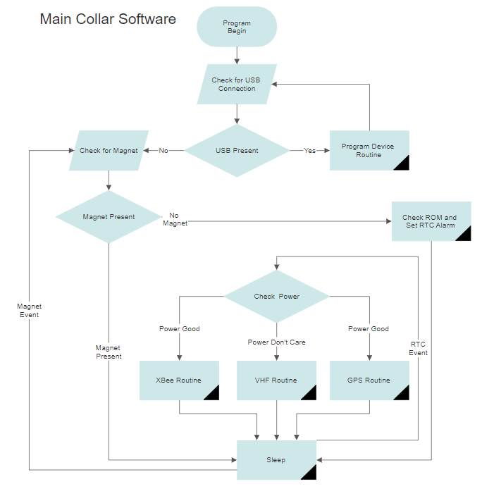

**Figure 2.** High Level Collar Software Flow

This top level software flow diagram shows the various logical operations for the main program. The microcontroller operation exists in essentially two states, deployed and programming mode. Programming mode is defined by the presence of a USB power connection. This leaves the device in a program device loop outlined in the Program Device Routine flow that follows. When the USB is removed, the device checks its magnet present line which acts as the activation “switch” for the device when in deployment. The USB line will be able to trigger an interrupt at any time to activate that connection mode. When the magnet is present, the device enters a sleep mode and will wait until an interrupt on the magnet present line wakes the device to check again. Once removed, the device will begin deployed operation. The First operation is to set the RTC alarms to wake up the device for module scheduling. Then the device enters sleep mode.

When the RTC wakes the device, the first operation is to check power left in the battery. The functional importance of the battery level check is to prioritize the VHF Routine for device retrieval over data acquisition. Once the power is calculated, the device will cycle through the subroutines.

### **4.8.2 Programming Device Routine Logic**

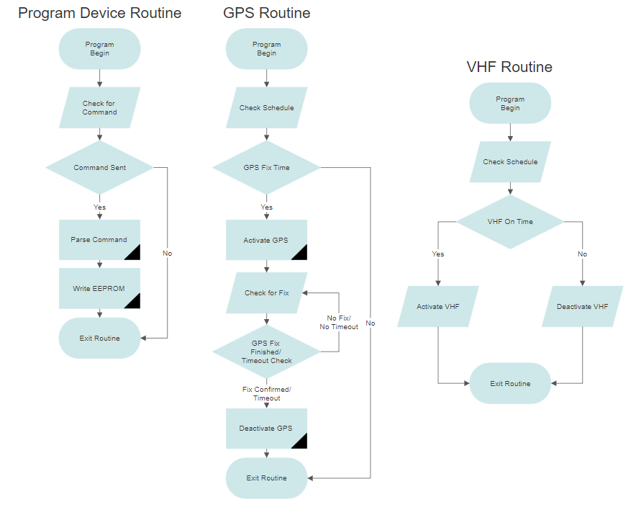

**Figure 3.** Programming Device Routine Flow

The program device routine simply checks for serial communications from the computer and returns to the main program if no communication was received. If communication is received in the buffer, then the command will be parsed and saved in the electronically erasable and re-programmable read only memory (EEPROM) as a operation schedule for runtime.

### **4.8.3 GPS Routine Logic**

  
**Figure 4.** GPS Routine Flow

The GPS routine starts by checking the EEPROM schedule. If the RTC data signals that the process should run the operation continues, or exits if not. If the process continues, the GPS module is activated. While active, the controller will check for a fix status from the GPS module. The controller will keep checking until a timeout is hit. When a timeout is hit or a fix is received, the GPS is deactivated and the routine is exited. The specific amount of time for timeout and acceptable fix quality will be configured from real data in build phase.

### **4.8.4 VHF Routine Logic**



**Figure 5.** VHF Routine Flow

The VHF routine operates off of the schedule. When the routine begins, the schedule is checked to see if the device needs to be on and sets the enable pin based on the result. Then it exits the routine.

### **4.8.5 XBee Routine Logic**

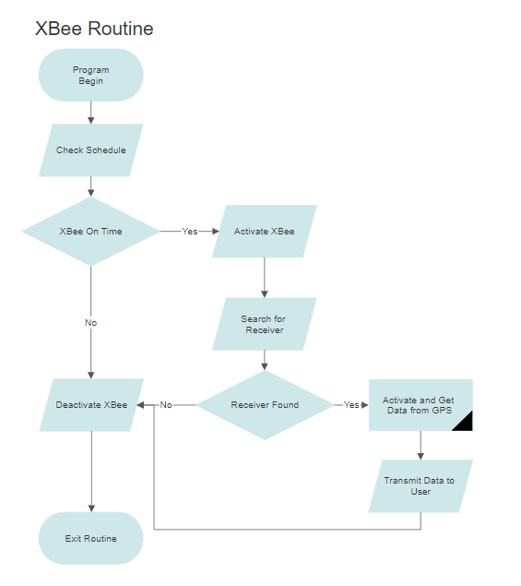

**Figure 6.** XBee Routine Flow

The routine for the XBee transceiver is configured for power savings. When the routine begins, the schedule is checked, if the XBee in in a transmit time frame, it is activated. It then searches for a receiver. If a receiver is found, then the GPS is activated to receive and send the stored data. After either result, the XBee is deactivated and the routine ends.

# 

# 5 Hardware Implementation

# 

Included below is an overview of each subsection of the electrical layout. Sections 5.1, 5.2, and 5.3 are common across both large and small collars, while 5.4 and 5.5 are specific to only the medium collar.

## 5.1 Power Source Selection

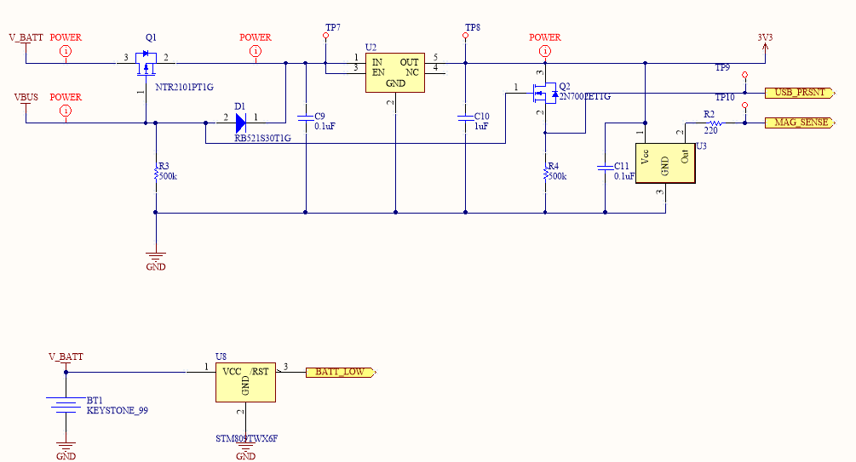

**Figure 7.** Power Source Selection Schematic

The power selection schematic shown in Figure 7 handles switching between the battery and the 5V USB whenever the USB is present. This schematic is present on both the small and medium version of the tracking collar. The linear regulator serves a dual purpose of maintaining a constant 3.3V from the battery throughout its charge life and lowering the USB voltage from 5V down to the required 3.3V. The PMOS on the battery input is used to isolate the battery from the circuit when the USB is present and prevent reverse current flowing to the battery from the USB. It also serves as reverse voltage protection if the battery is installed in the wrong direction. The diode on the USB input prevents the battery voltage from interacting with the gate of the PMOS and driving the PMOS to its off state. Power loss in the diode is irrelevant because the power would be coming from the USB input and not draining the battery. Simulations for this circuit can be found in Appendix B.

An NMOS is present between the output of the linear regulator and GND. When the USB is present the NMOS is driven to its active state, which causes the USB_PRSNT signal to be driven high, indicating to the microcontroller that the USB is present.

An active low hall effect sensor is present at the output of the linear regulator. When a magnet is present the MAG_SENSE signal is driven low, indicating to the microcontroller that the magnet is present. When the magnet is removed the sensor drives the signal high. This is the activation switch of the device when in deployment mode.

Additionally, a battery supervisor IC has been included to alert the MCU to a low battery condition. This condition is checked as a threshold voltage and returned to the MCU on a GPIO pin.

## 5.2 Microcontroller

# 

**Figure 8**. Microcontroller Schematic

The microcontroller section is responsible for tying all existing signals back to the microcontroller. Among these are the Serial Peripheral Interface (SPI) communication lines for the XBee and GPS modules, as well as signals from the power selection section. Also located on this sheet is the power conditioning for each of the power pins on the controller. These are provided in order to provide stable, clean power to the processor.

The included crystal is a 32.768 kHz crystal, which will directly feed the onboard RTC. Inside the STM32L011 is a phase locked loop (PLL) which can use the input clock and derive a very accurate internal clock signal at much higher frequencies. With the single external crystal, the processor can run at a range of internal frequencies, such as 2, 4, or 16 MHz.

The header J1 is for programming of the processor and (for the large collar) VHF beacon. The processor is programmed via Serial Wire Debug (SWD). The UART connection for the configuration program is also included on this header.

This schematic is common between both collars, however the small collar does not include some of the power control outputs and has only one SPI connection.

## 5**.3** **GPS**

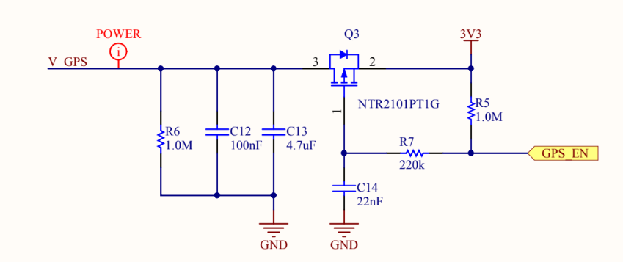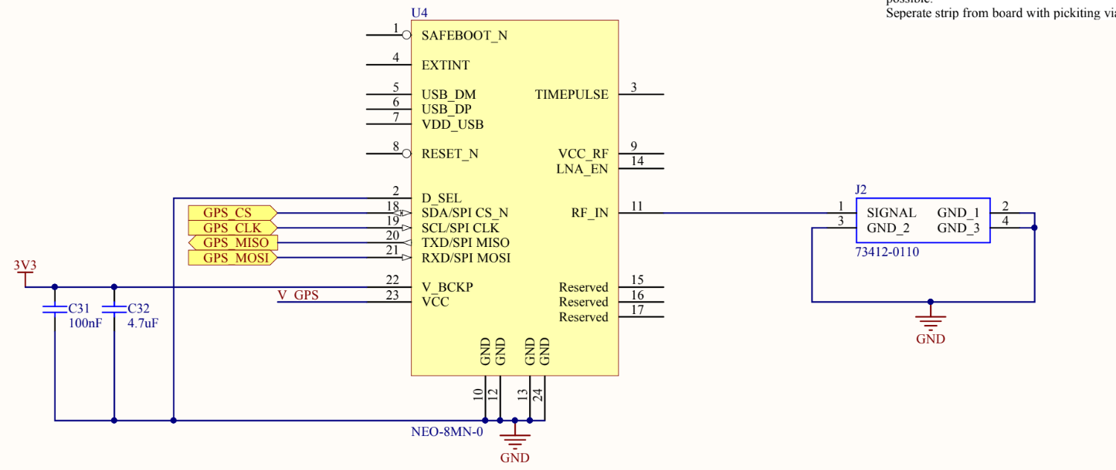

**Figure 9.** GPS Schematic

The GPS circuit is driven by the PMOS module selection circuit seen in the top of the Figure. This circuit operates on inverted logic for the enable pin. When the GPS_EN pin is pulled high, the R5 resistor ensures that the GPS_EN line is pulled high and the PMOS is disabled, deactivating the GPS device. When the GPS_EN line is driven high, the PMOS is activated and current can flow through to the V_GPS from the 3.3V rail. When the device is deactivated again, R6 ensures that the power line is pulled low. This circuit is common among the GPS, VHF, and XBee modules in the medium collar, the small collar, again, only incorporating the GPS module.

The NEO-8MN module has multiple communications modes, in order to configure it for SPI communications, the D_SEL pin needed to be pulled to GND. The V_BCKP line is tied to the 3.3V rail to keep its ultra low power RTC enabled which allows for drastically reduced startup times and overall power savings.

The antenna is attached via a microstrip to the RF_IN pin. This strip needs to be as small as possible and separated from the ground plane around it with both a keepout and picketing vias. The line does not need an additional LNA or SAW filter like most passive antenna components because the device has internal filters and amplifiers.

## 5**.4** XBee

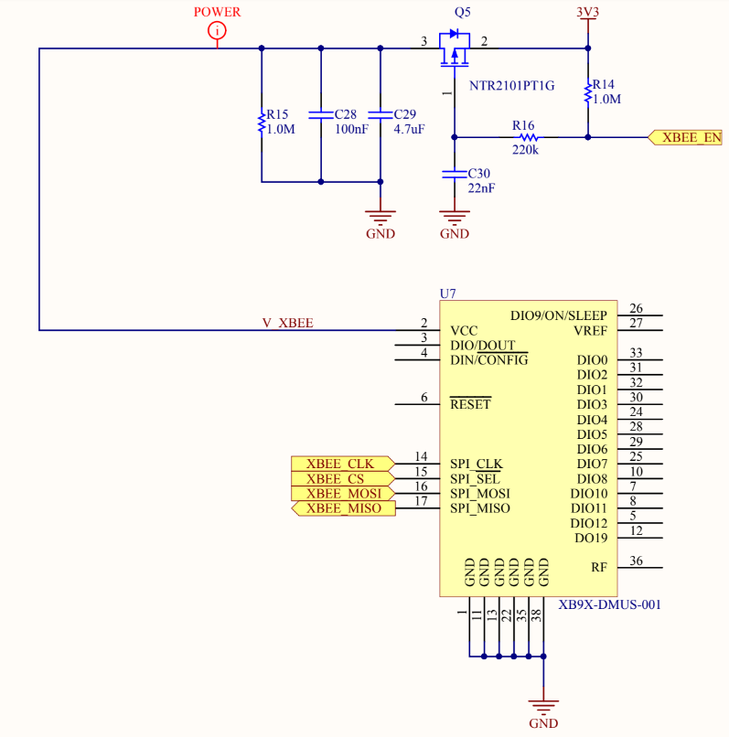

**Figure 10.** Xbee Schematic

The XBee device, only appearing in the medium collar design, operates on the same device selection circuit outlined in Section 6.3. This allows the device to be shutdown when not in use. The only other connections needed are the SPI lines to communicate with the MCU.

## 5.5 VHF Beacon

# 

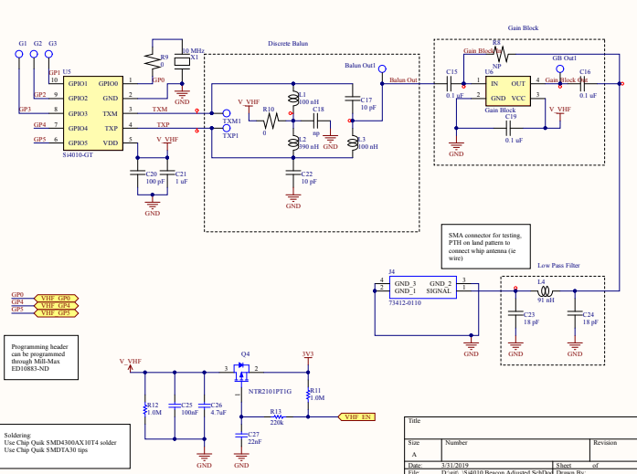

**Figure 11.** VHF Beacon Schematic

The VHF beacon schematic shown in Figure 11 was copied directly from the documentation provided from Brian Westra’s thesis, with a small modification in the power input. In the original design the schematic and PCB were designed to be a standalone board with a Hall effect sensor to control the on-off functionality of the beacon. To effectively integrate the schematic into the general design, the Hall effect sensor circuit was replaced with the PMOS circuit consistent with the other devices, outlined in Section 6.3, for the on-off control. When the VHF_EN signal is set high than the gate of the PMOS will be driven high and the PMOS will be in its off state. When the signal is low then the gate of the PMOS is driven to GND and the beacon circuit is connected to the 3.3V power line.

## 5.6 Printed Circuit Board

In order to provide a robust mounting and connection solution, a printed circuit board was designed. This board connects all components together and allows for easily reproducible circuits. 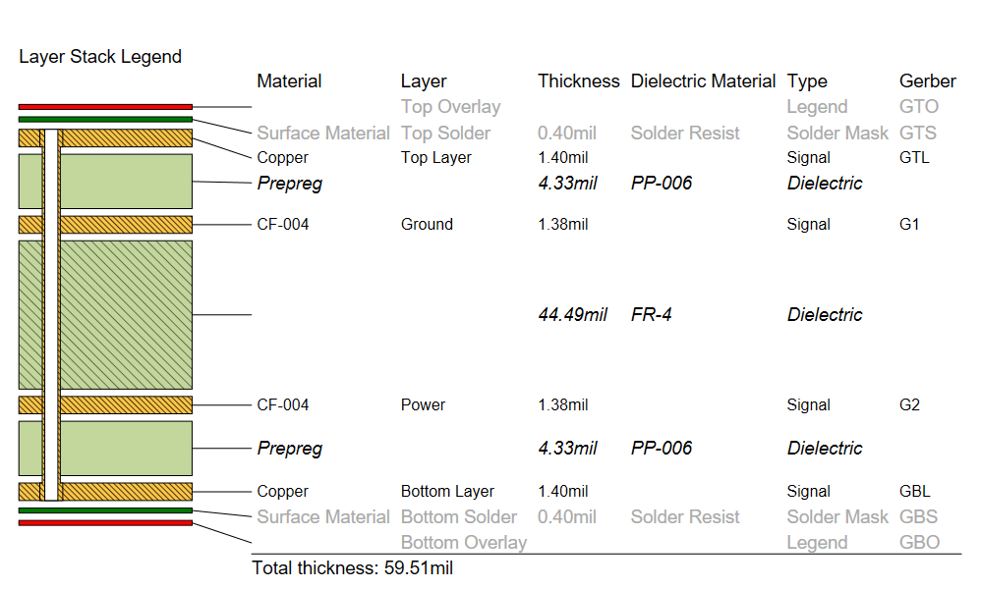

**Figure 12.** Board Layer Stackup

The PCB was designed with a standard 60mil (1.6mm), four layer stackup. No microvias were used in order to reduce manufacturing cost. Since there are no high currents present in the circuits, a 1oz copper pour is sufficient for both inner and outer layers. The internal ground plane was placed directly below the top layer, which includes the VHF beacon. This was done to provide the VHF circuit with a sufficient ground plane. An additional power plane, mainly populated with a 3.3V pour was also placed on an inner plane. Both outer planes are used for signals, with a ground pour fill. This stackup is common between both collars.

Calculations were performed to ensure that the traces were short enough as to make trace impedance callouts unnecessary. These calculations were performed with the Saturn PCB Design calculator and are shown in the figure below.

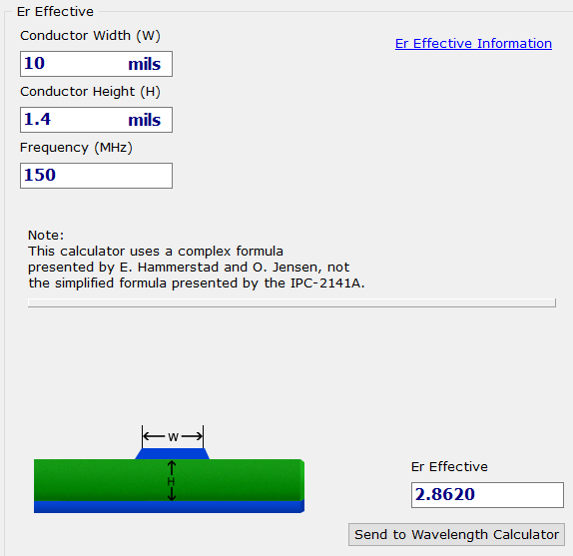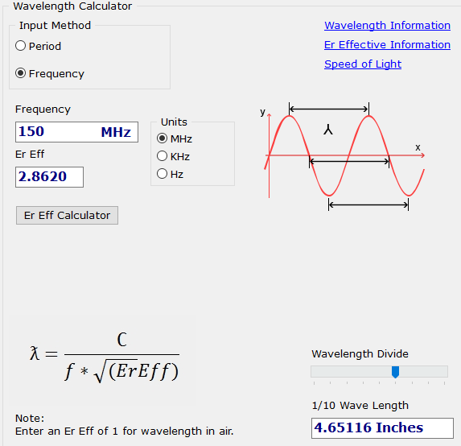

**Figure 13.** VHF Wavelength Calculation

The VHF frequency chosen for the calculation was the worst case frequency of 150 MHz. On this board, the 1/10 wavelength was found to be around 4.6 inches, which is far longer than any modes that would be supported, or any microvias would be in length.

**Large Collar Copper**

The large collar top layer includes the power control circuitry, the microcontroller, the battery mounts, and the VHF beacon. The upper left corner contains the VHF beacon. The components were placed as close together as possible to reduce trace length of high frequency nets, with longer traces impedance controlled to 50Ω. The large pads in the center are for the battery clips. Mounting holes are provided for fixing the board in the stencil printer.

The VHF and GPS modules are located on the bottom side of the board due to space constraints.

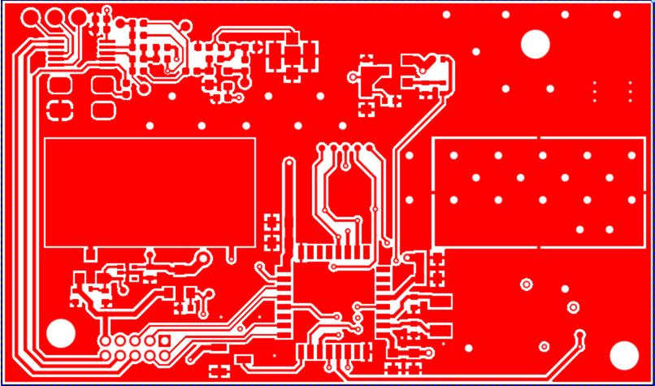

**Figure 14.** Large Collar Top Signal

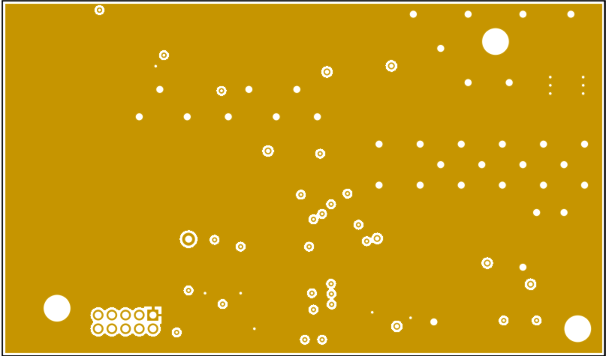

**Figure 15.** Large Collar Ground Plane

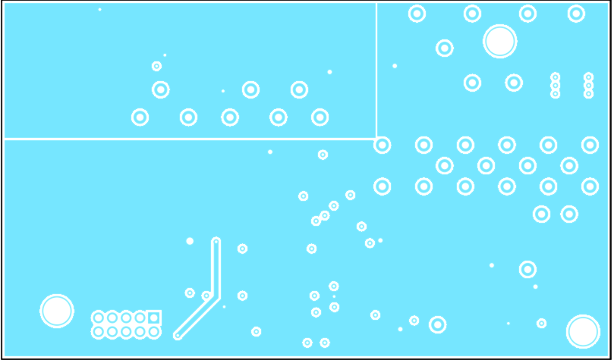

**Figure 16.** Large Collar Power Plane

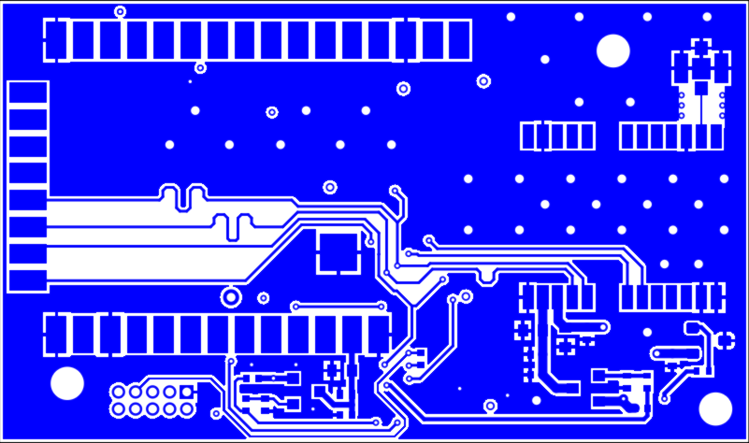

**Figure 17.** Large Collar Bottom Signal

**Small Collar Copper**

The small collar is constructed in a similar manner to the large collar,with the exception of not including the VHF or XBee modules. The design practices are largely the same.

# 

**Figure 18.** Small Collar Top Signal

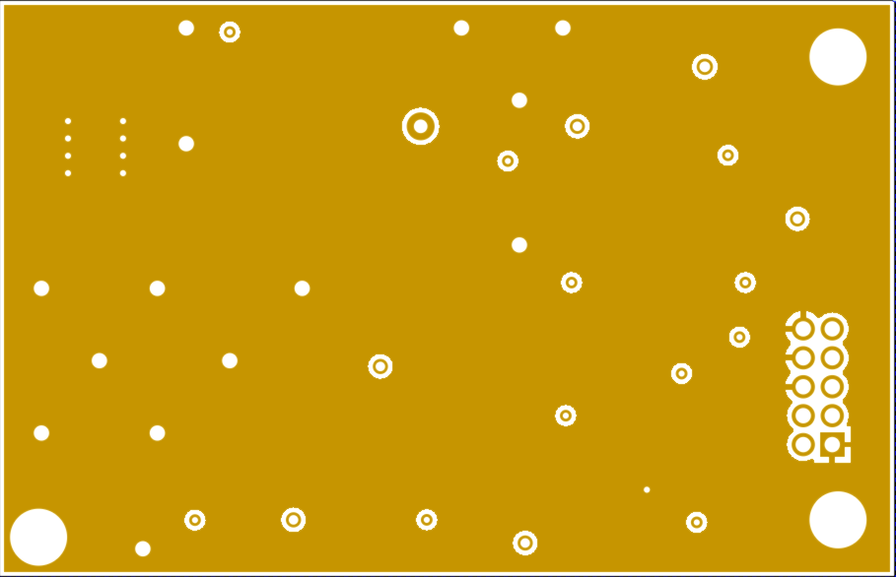

**Figure 19.** Small Collar Ground Plane

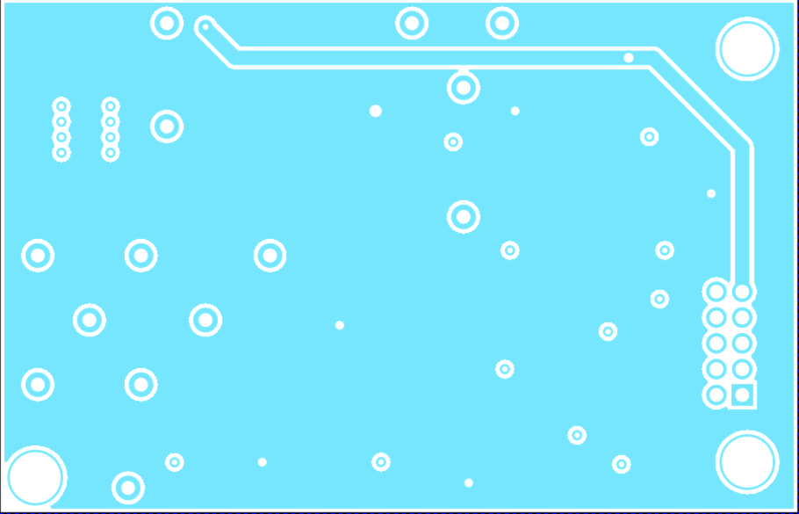

**Figure 20.** Small Collar Power Plane

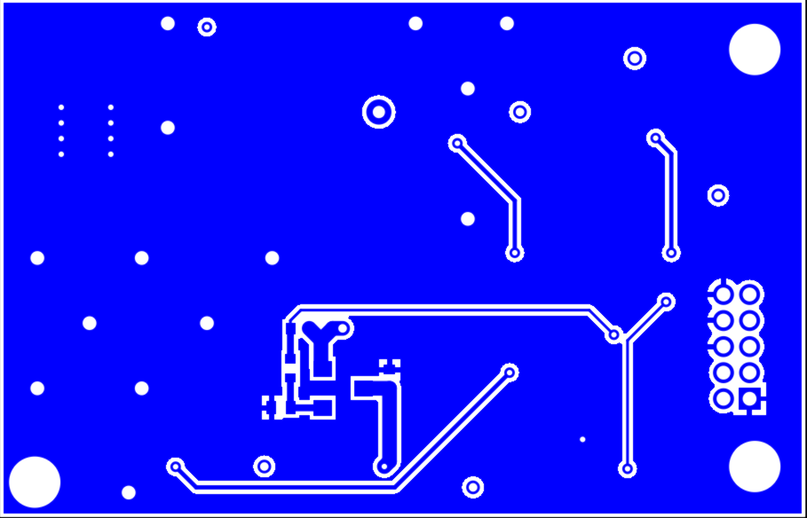

**Figure 21.** Small Collar Bottom Signal

# 

# 

# 6 Packaging Design - Medium Collar

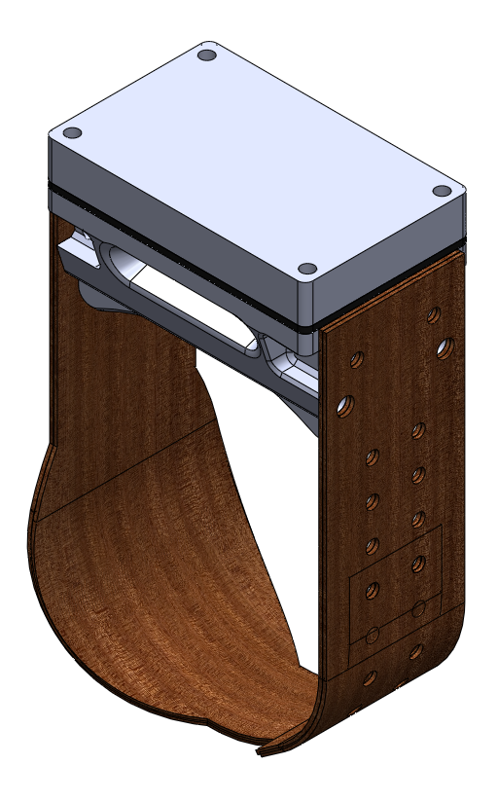

**Figure 22.** Medium collar 3D concept rendering.

## 6.1 Enclosure Design

The enclosure for the GPS collar targets the smallest size and weight possible. The housing targets for these metrics are defined by specifications 3.1.1.1 and 3.1.1.5, which the team has projected benchmarked based on the previous years’ projects. These are target metrics and are the maximum allowable values for the size and weight of the tracking device. A weight budget figure is shown in Figure 23, which details the makeup of the device in terms of component masses. The enclosure design focuses on further development of the 2017 project’s design to scale the enclosure down, and provide a more ergonomic and comfortable fit around the animal’s neck. Based on GPS antenna design discussions, the decision was made to reduce the number of enclosures from two separate enclosures (with GPS module on the top of the device), to one enclosure that contains all of the electronics (with the GPS antenna secured in the collar material for signal acquisition).

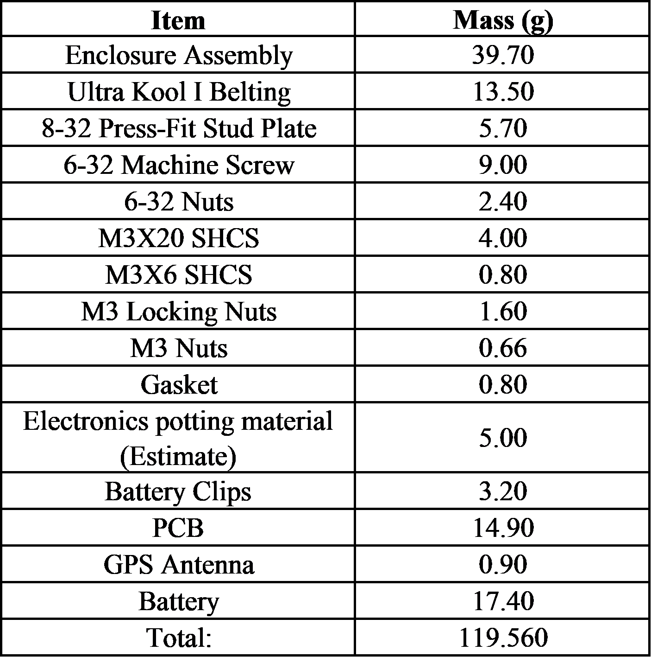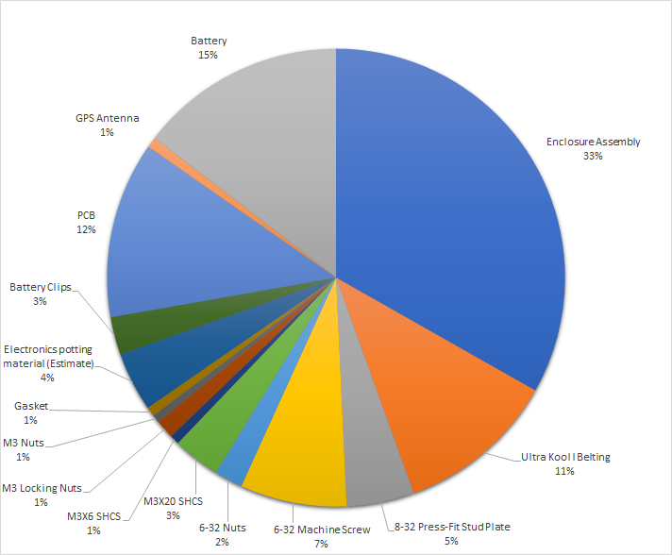

**Figure 23.** Weight Budget for Medium Collar

The enclosure must withstand the bite force from a predator and be resistant to abrasion from kittens scratching on the collar (specification 3.1.1.2). Along with being a strong and durable material, the enclosure must resist water absorption and be low density to provide reduction in weight. Based on these specified requirements, a weighted material selection matrix was used to determine the best candidate materials for the housing. The sequence of tables is displayed in Table 9. Based on the matrix, Carbon Impregnated ABS, standard ABS, and a Polycarbonate-ABS blend are the top three materials. Taking reproducibility into consideration for future models, Carbon Impregnated ABS was determined to be the best material for the enclosure. If a vendor cannot be found to 3D print Carbon Impregnated ABS, other suitable materials include Polycarbonate-ABS or Nylon impregnated with Carbon Fiber.

**Table 9.** Material Selection Matrix Sequence for Electronic Enclosure

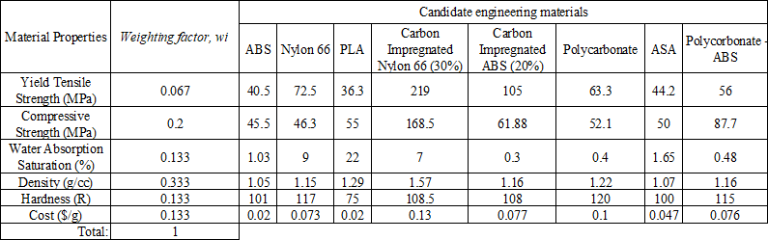

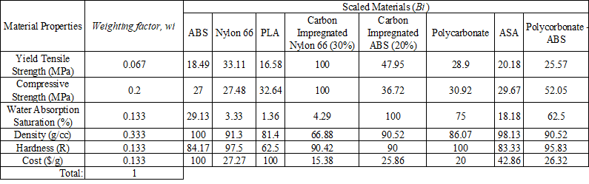

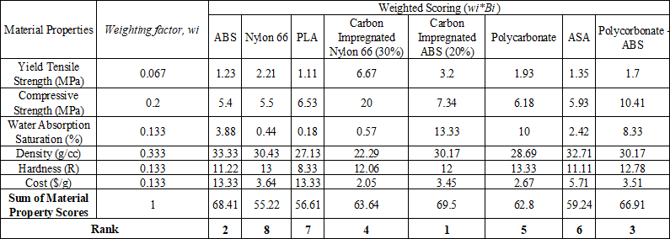

Specification 3.1.1.2 requires the enclosure to withstand a bite force of 400 lbs. FEA was performed on the components of the enclosure to verify that the components will not permanently deform upon the predator’s bite. A 400 lb bite simulation distributed among 8 different points on the housing was performed to prove the enclosure will not yield even under the pressure of a predator bite.

Electronics are held in place using epoxy integrated into the lid of the enclosure. The antennas are the only components not contained in the main enclosure and are housed in the strap of the collar. The connection point between the collar and the strap is sealed water tight and will provide strain relief for the connection. To improve the durability and water-proofing of the electronics the entire circuit board, and save some contacts for programming, the antenna and battery stand-offs are set in epoxy resin. This takes place after mounting the circuit board in place, permanently attaching the electronics to the enclosure. The potting of the electronics will ensure that no moisture will be able to reach the circuit board per specification 3.1.4.1. The entire enclosure will be sealed using a gasket as described in section 6.1.1 of this document.

Enclosure strength is another consideration for the design. Predation by wolves is a rare occurrence according to the sponsor, the possibility of a predator bite would be a worst case scenario for the medium collar design. To help camouflage from predators, the enclosure is black in color and collar belting is brown per specification 3.1.1.6. If a predator were to bite, the enclosure must not yield or break under stress. This would result in the exposure of the electronics to the environment, and eventual failure.

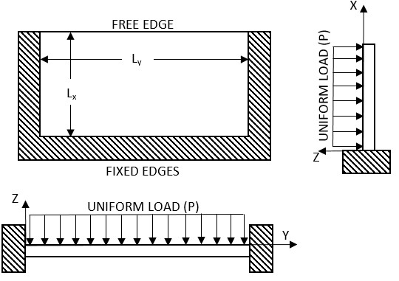

**Figure 24.** Illustration of simplified model of enclosure side under uniform loading.

The longest unsupported side of the enclosure was modeled under a uniform load of 200 lbs. The face of the enclosure bottom was simplified to be a thin plate, 4 mm thick. The length of the plate was taken to be 65 mm, and the width 30mm. The thin plate will be considered fixed on three edges, with one edge free. The flat plate under uniform load is illustrated in Figure 24. The uniform load was calculated by dividing the force, converted to newtons, by the area in meters squared as shown in equation 1, below

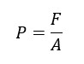 (1)

Where P is the load on the plate, F is the force applied over the plate’s area, and A is the area of the plate.

A large displacement of the free edge of the enclosure body will result in the seal between the surface and the gasket breaking. This seal must remain intact to ensure the components remain dry during operation. The maximum stress in the side of the body must remain below the yield strength of the Carbon Fiber ABS to ensure that any deformation is not permanent. The maximum deflection and the maximum stress in the plate can be calculated using equations 2 and 3, respectively, shown below.

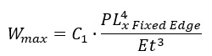 (2)

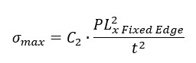 (3)

Where W is displacement, C1 is a constant, P is the load on the plate, L is the length of the fixed edge along x, E is Young's modulus for carbon fiber ABS, t is the plate thickness,C2 is a constant, and σ is the stress in the plate. The constants C1 and C2 are related to the proportion between the length and width of the plate, Ly over Lx. Roark’s formulas for stress and strain gives these constants to be: C1 = 0.165 and C2 = 1.373 interpolated from a table of known values for materials possessing a Poisson's ratio near 0.3.

The displacement was calculated to be 0.142 mm. This is for one side of the enclosure. If the edge of the body was to shift .142 mm the seal should not break. The gasket is compressed 0.6 mm and the motion is along the face of the gasket. This should not result in failure. The maximum stress in the plate was calculated to be 35.25 MPa. The yield strength in tensile loading for carbon fiber impregnated ABS is 105 MPa. This results in a factor of safety of 2.98. The simplified model shows that the carbon fiber ABS exceeds the strength requirements for the enclosure.

Finite element analysis, FEA, was also used to determine the stresses under loading for an enclosure comprised of 20% by weight carbon fiber impregnated ABS. Wolves can produce a bite force of 400 lbs that would be spread over their canines and sharp premolars. Canine dentition is specialized for ripping and tearing resulting in point forces at the tips of teeth that are used to puncture the outer skin of prey. The bite from a predator on the enclosure was modeled as eight point forces (based on specification 3.1.1.2.1), representing four upper and four lower teeth, as shown in Figure 25, below.

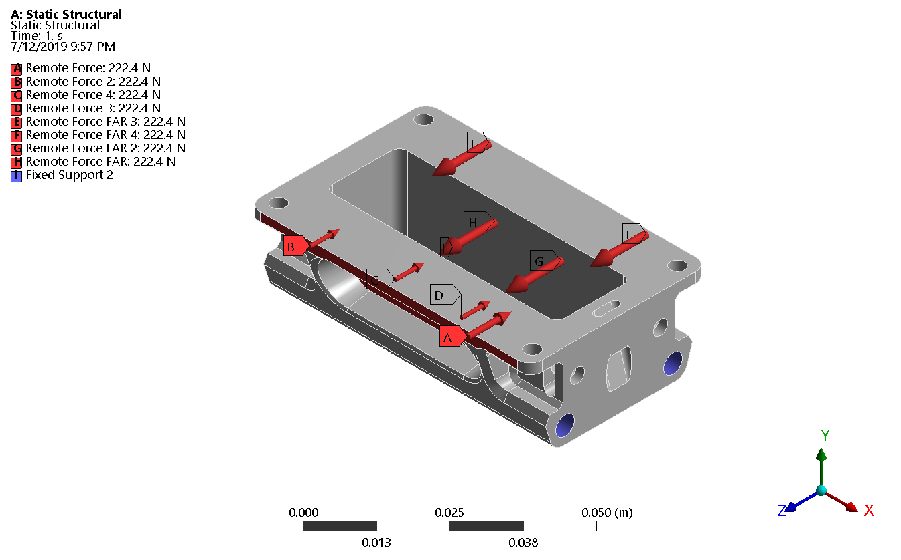

**Figure 25.** Computer model setup for FEA in ANSYS. Remote forces used to simulate bite forces spread over 8 teeth.

A remote force of 222 N, approximately 50 lbs, was applied at eight points as shown. The assumption is that the full force of the 400 lb bite force is distributed evenly over the eight points and that the forces will be inline with each other. The base of the model is fixed and the lid and the bottom of the enclosure are bonded where the threaded fasteners pass through them. The results of the FEA is shown below in Figures 26 and 27 for deformation and maximum stress. The total deformation of the collar enclosure was found to be 0.15 mm.

The model shows that under the applied forces the enclosure will not yield. The maximum force experienced by the enclosure is 38.3 MPa and the carbon fiber impregnated ABS has a yield strength of 105 MPa. The enclosure should not deform permanently under the stress of a predator bit in the event of an attack. This will ensure that in the unfortunate instance of an attack on a specimen being tracked, their data set will still be retrievable.

## 

**Figure 26.** Total deformation, 0.15 mm, of enclosure under 400 lb bite force. Total deformation calculated using FEA.

## 

**Figure 27.** Maximum equivalent stress, von-Mises, of enclosure under 400 lb bite force. Maximum stress predicted to be 38.3 MPa.

The enclosure assembly was tested using an instron and proven to withstand over 400lbs of force. This is documented in section 3.1.2 of the validation documentation.

## 6.1.1 Collar Strap Connection

The enclosure is connected to the collar strapping by two 6-32 threaded fasteners. The enclosure will not bear any tensile loads due to this connection because the tensile load is transferred through the rods. The collar strap must ensure that the collar and enclosure remain as one piece. Specification 3.1.1.3 states that the collar strap shall have a tensile strength of at least 7.5 MPa. The tensile strength will be used to determine the maximum load that the collar must withstand without failing. The collar strap is made from two layers of polyurethane belting. A mathematical model of the strap under loading was created to determine the bearing stress of the collar under tensile loading. The bearing stress will be concentrated around the holes supported by the 6-32 threaded fasteners. The model is illustrated in Figure 28, below.

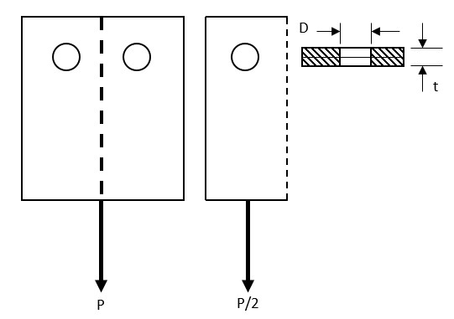

**Figure 28.** Strap material under tensile load, P. Bearing stress will occur at the through holes supported by m4 threaded rods.

The bearing stress in the strap is given as the force over the cross sectional area of the holes in the strap. The bearing stress for one through hole in the strap can be calculated in equation 4, below, where P in the equation is illustrated as P/2 in Figure 28, above.

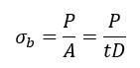 (4)

Where σb is the bearing stress, P is the load in Newtons, A is cross-sectional area of the hole, t is the thickness of the material, and D is the diameter of the hole. Rearranging to solve for the maximum allowable P yields equation 5, below.

 (5)

Where Pmax is the maximum allowed load for one hole, σmax is the maximum bearing stress, as per the specifications, for a 1 mm thick strap, 2 layers thick, t is material thickness and D is the diameter of the hole. This calculation is for symmetric loading over two holes, as illustrated in figure 27. Where Pmax total = 2*Pmax and σmax = 0.5*σmax total = 3.75 MPa.

The model is simplified to consider just one half of the strap due to symmetry in the geometry and the loading. The maximum stress that is allowed by the strap is 7.5 MPa. The load is carried over two holes in the strap, having diameter 4mm, the strap will withstand a load of 13.33 lbs. The belting selected has a tensile strength of 7.95 Mpa, and exceeds the specification for the strap material.

The belting was tested successfully with the fully assembled enclosure. See validation document section 3.2.1.

## 

## 6.1.2 Enclosure Sealing and Gasket

The animal tracking collar must withstand moisture exposure. A test to determine the waterproofing of the enclosure was conducted to prove that the design is water resistant. The gasket was cut from a closed cell rubber neoprene, a blend of Styrene-butadiene rubber and ethylene propylene diene terpolymer (EPDM). The blended rubber gasket was successfully tested and met the specifications listed above.

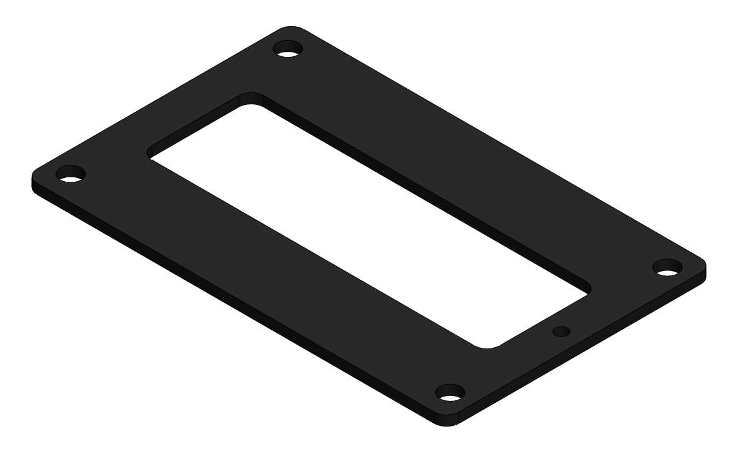

**Figure 29.** Screenshot of cut-to-design rubber neoprene gasket.

The enclosure was 3D printed using ABS with 15% carbon fiber by weight. ABS impregnated with carbon fiber has a water absorption of 0.3% over a 24 hour period (saturation) resulting in the design being dimensionally stable in wet environments. ABS is not generally considered for outdoor applications due to moderate UV resistance. With the collar enclosure being deployed on a nocturnal animal for a period of 6 months ABS will be sufficient.

The gasket will be hand cut and will seal the connection between lid and enclosure bottom. The enclosure will be sealed when the lid is fastened in place. Four M3 button socket cap screws at the corners of the lid will be tightened. The force is distributed over the bottom edge of the lid, deforming the gasket from a thickness of 1.59mm to 1mm, completing the seal. The enclosure’s seal and waterproofing were tested and verified using an underwater test at 0.5 meters for 1 minute and a water jet test to ensure the IP rating.

## 6.2 Collar & Fasteners

The collar material is very lightweight, non-agitating to the animal, and strong. The material of choice for the collar that meets the requirements and is a Polyurethane - Monofilament Polyester belting material (Ultra-Kool 1: 03-133) supplied by SPARKS belting. The Polyurethane belting is very strong, lightweight, maintains a smooth texture, and is very durable.The collar strapping material is affixed to the enclosure on both sides of the enclosure with a size adjustment point on the back side of the collar. The adjustments on the collar allow the field researcher to adjust the collar from 210 mm to 300 mm, in increments of 10 mm, per specification 3.1.1.8. The collar strap being made from a bilayer polyurethane belting sleeve encloses and protects the antenna (as well as any external wiring) directly as it exits the housing per specification 3.1.1.4. The antenna passes through only one side of the enclosure. The antenna passthrough consists of a small hole waterproofed by a gasket and potting epoxy. The passthrough allows the antennas’ wires to pass from the electronics enclosure to the collar sleeve. A channel for the antenna to exit the housing protects the junction, ensuring zero external exposure. The bilayer collar is fused at its edges, creating an enclosed sleeve on one side of the collar. The sleeve provides protection for the antenna and connecting wires while not interfering with signal acquisition.

The antenna side of the polyurethane sleeve collar is roughly 200 mm long. The strap will distribute the weight of the collar over a large area of the specimen’s neck to ensure no pinch loads are present from any wires within the sleeve. This will help to prevent skin irritation and agitation of the animal. The antenna strap is 183 mm and tapers from a 36 mm width to a 24 mm. The non-antenna side of the collar is 110 mm long, and will maintain the bilayer sleeve design. This portion of the collar will contain the adjustment holes in increments of 10 mm, the strap width is 43 mm allowing the end of the longer antenna sleeve to slide into the non-antenna sleeve for adjustments. Upon adjusting, the collar remains internal to itself ensuring there is no loose material that can be tampered by external forces or the environment.

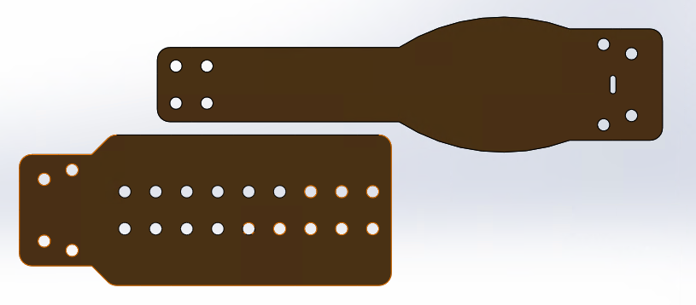

**Figure 30.** Collar sleeved straps.

The collar straps will be secured on both sides of the housing by two 3in machine screws. These rods run the length of the enclosure with each end terminated by a nylon retaining nut, securing both collar sections and bearing the majority of forces during deployment.

A small flat 8-32 male stud plate with a washer plate and nylon locking nuts will be used to select the appropriate size of the collar, and to secure the two sides of the collar together. The reason for selection of the Imperial System for the adjustment plate is that the male stud threads were not available in metric sizes. This stud plate will be low profile with two male threads protruding from the inside of the collar sleeves. The plate will be protected by the interior sleeve layer to ensure no irritation to the animal during deployment. This fastener will be custom produced by the team, but can be further outsourced if more devices are necessary in the future.

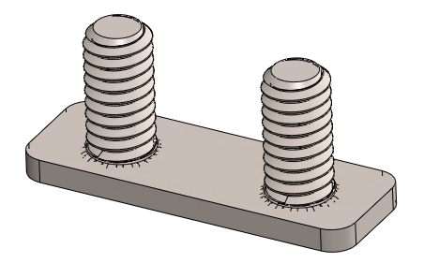

**Figure 31.** 8-32 Stud Plate.

## 6.3 Packaging Component Validation

Per the requirement of the medium device needing to be field deployable, component validation testing will be conducted to verify the performance of the chosen components. Size and weight will simply be measured directly from the finished device to certify that the collar meets the sponsor’s size (volume) and weight requirements mentioned above. Further testing on the enclosure and collar material will be performed as detailed in the following sections.

**Enclosure - Strength**

The strength of the enclosure will be validated using a machined fixture and the instron machine at GVSU’s Keller laboratories. The enclosure will be secured in the fixture on the two likely surfaces to be bitten by a predator. The fixture will include 8 points of contact (4 on the long outward facing side of the housing, and 4 on the long inside face) to simulate a bite from a predator. The fixture will be contain a top and bottom plate that will sandwich the enclosure (each plate contains the 4 bite-point features). The conducted validation test will test the enclosure to verify the strength of the enclosure per the specifications mentioned above. If the enclosure yields prior to the specified maximum strength, corrective actions will be taken to improve the strength of the enclosure and verify that the specifications are met.

**Enclosure - Waterproofing**

Waterproofing of the enclosure will be conducted following the procedure used by the 2017 GPS

Collar group conducted their waterproof tests. The validation test will consist of placing a dry piece of paper into the fully assembled enclosure and submerging it in a bucket of water for approximately 30 seconds. If no air bubbles are seen exiting the housing, and once removed from the bucket and the paper remained dry the enclosure will be considered waterproof. An additional simulation will also be conducted to verify the waterproofing ability of the enclosure. With the piece of paper in the enclosure, it will be secured in place and sprayed with the typical garden hose (approximate flow rate of 20 liters per minute). This simulation will further verify the waterproofing of the housing. If there is visibility of bubbles, or the piece of paper contains moisture, corrective actions will be taken to improve the water resistance and ensure the specifications mentioned above are met.

**Collar - Strength**

The strength of the collar’s belting was verified by the supplier specifications (SPARKS Belting). Further testing will be conducted by securing two pieces of the collar to a fixed point, securing the adjustment fastener to the second collar material piece, then hanging the maximum loading stress weight from the loose end. As the material maintains its integrity through the maximum loading scenario it will be verified to meet the specification for strength by enduring a load of 13.33 lbs. If the collar material yields prior to the specified maximum strength, corrective actions will be taken to improve the strength of the collar and ensure that the specifications are met.

## 6.4 System Validation

To validate system functionality (explained in Section 2.1.2), the complete collar assembly will be brought outdoors and placed onto a simulated animal. The capability of the GPS to get a fix will be verified along with the wireless and wired data downloading capabilities. The collar will also be tracked with the VHF to verify that it operates properly. This testing will simulate how the collar will operate when used by the researcher.

The user interface will also be tested to ensure that there are not any configurations or arrangements of inputs that will cause an error in the system. This will be done by stepping through different sets of inputs and verifying that the system still operates as intended.

## 

## 6.5 Mechanical Fabrication and Assembly Overview

Fabrication of the packaging components will be done in-house with the mentality that fabrication could be performed by a technician in the future. The electronics enclosure will be 3D printed using the ABS - Carbon Fiber filament mentioned above. The team will purchase a hardened steel printing nozzle sop that the enclosure body and lid parts can be printed on personal machines. This route of fabrication This fabrication could also be outsourced to a prototyping firm such as Protolabs in the future.

The lid of the enclosure is hollow to mount the pcb. The pcb and electronic components will be potted within the lid using an epoxy resin. The battery terminals will extend beyond the epoxy allowing for the battery to be field replaceable. The lid will be seated on the top of the enclosure bottom and secured in place with 4 m3 fasteners with nylock nuts. When secured in place the lid will provide 0.6 mm of deformation in the EPDM gasket that is seated between the lid and the bottom enclosure, resulting in a watertight seal.

The EPDM gasket is comprised of a high density foam impregnated with rubber. The combination allows the gasket to deform easily sealing the enclosure. The 2018 satellite collar employed a similar design with the same gasket material. The design was proven to be effective and will be implemented in this collar design.

The collar strap material will be cut manual, or outsourced to a laser cutting service. The manual operation allows for quick, easy, cheap, and in-house production of the collar strap. The laser cutter will provide superior dimensional accuracy over traditional cutting methods. Hole alignment, and accurate placement, is essential for the collar adjustment to work properly. The two layers of polyurethane belting will be placed face to face with the antennas inside. With the layers of belting laying face-to-face, with polyurethane layers on the inside, they will be fused together with heat: melting the interior layers together, forming a uniform sleeve. The antenna will be enclosed securely within the collar strap. The adjustment side of the collar will be fused roughly 3mm on each side creating a pocket for the tapered antenna strap to feed inside.

The belting will be attached to each side of the housing by 3 in long 6-32 machine screws secured with retaining nuts. The retention nuts will not back off the threaded rod, preventing the strap from coming loose. The antenna strap will have two additional m3 fasteners holding the end in place, creating a small pocket for the antennas to pass through to the collar strap. The two open ends of the collar strap will be connected using a stud plate. The stud plate will have two 8/32 threaded studs that will protrude from the end of the antenna housing strap, through the top layer of the shortened strap. The size of the collar will be selected by passing the studs through the appropriate holes in the adjustment strap. The protruding studs will be fitted with 8/32 threaded nylock nuts to prevent the strap from coming loose.

# 7 Packaging Design - Small Collar

# 

## 7.1 Collar Design & Waterproofing

The small collar design incorporates minimal functional features of the medium sized collar design to prioritize form factor over durability and longevity. The small collar is to be as lightweight, and as small as possible per specifications 3.1.1 and 3.1.4 respectively. The collar strap material will be made from a single layer of the same polyurethane belting material used in the medium collar, and the electronic components will be attached to it using a heat shrink tube. The collar’s circumference will be adjustable from 90 mm to 190 mm, in 5 mm increments. The collar will be made adjustable using an M3 fastener and a retaining nylon nut. The attached electronics will be potted in epoxy resin. The potting process ensures that the electronics will remain dry and adds a level of protection from abrasion and impact. A weight budget for the small collar is shown in Figure 32.

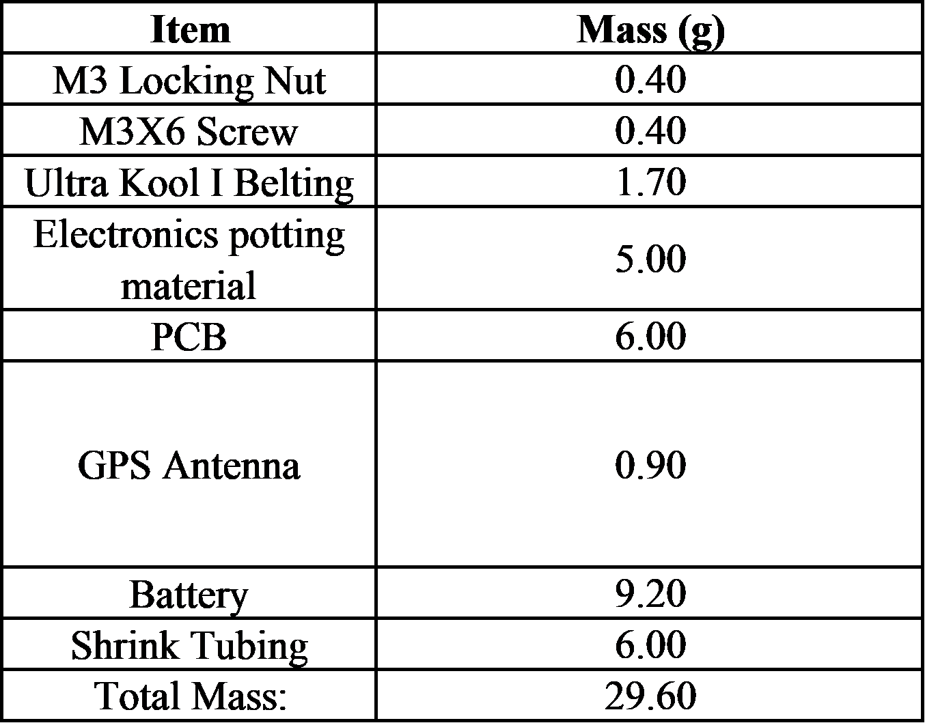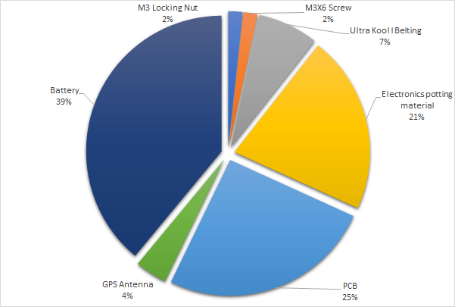

**Figure 32.** Weight budget for small collar.

The electronics are designed to fit within one potted package, with the GPS antenna being integrated into the module. The battery will be separate from the potted electronics, held in place by the battery contacts, and secured in place to the collar with heat shrink tubing. The battery will not be field replaceable. Per the sponsor’s request, the design will be minimized in size and be based off of a provided prototype device.

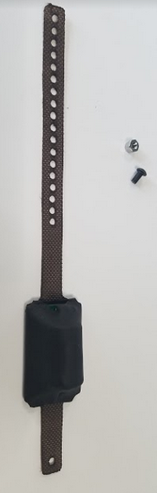

**Figure 33.** Photograph of small collar.

# 

# 8 Deliverables

The following fully functional items will be delivered to the sponsor: A fully assembled, fully functional, and field deployable medium sized and small sized collar will be provided by the team. The team has utilized a previously developed receiver with USB interface; created by the 2017 GPS Collar team, to wirelessly access the logged data of the medium collar. Both collars will include a physical data port to allow for download of data and configuration. The collars developed by the group are compared to the 2017 groups device as well as competitor devices in Table 10.

**Table 10.** Comparison of Current Team’s Collars to Previously Developed Collars

|  |  |  |  |  |
| --- | --- | --- | --- | --- |
| Collar Device | 2019 GVSU Medium Collar | 2017 GVSU Collar | Litetrack 60 (Medium) | 2019 GVSU Small Collar |
| Strap Width (mm) | 35 | 30 | 15 | 10 |
| Circumference (mm) | 210 - 300 | 450 - 500 | 210-390 | SMALL |
| Weight (Grams) | 125 | 135 | 63 | 35 |
| Xbee Range (m) | 125+ | 100 | N/A | N/A |
| Vhf (Life in Days) | 150 | 150 | 150 | N/A |
| Cost ($) | ~$385 | ~$530 | (Prohibited) | ~$285 |

A field user manual and a technical user manual have been provided. The technical user manual is for debugging, system customization, and detailed assembly/configuration instruction purposes. This manual also includes detailed fabrication section on how to reproduce the device. A separate manual has been provided for basic programming/configuration and operation of the collars. A battery calculator excel file is also included with the field user manual to estimate the battery life of the collars given specified input parameters. A complete bill of materials including suppliers, part numbers, and costs is provided for each collar so that future reproduction can be performed with ease.

# 9 Social and Engineering Impact

**9.1 Social, Economic and Environmental Impact**

The Grand Valley State University’s biology department, specifically Dr. Keenlance, has worked with the School of Engineering for several years on developing instruments for his research. Often these projects are proof of concepts and move towards the ultimate goal of producing tools for the advancement of biological research that will affect the future of ecological and animal conservation.

The 2019 Animal Collar Project, as detailed in this document, is more than a piece of technology. The successful deployment of one collar for Dr. Keenlance’s study of American Martens and Bobcats is a small success. The overarching goal of this year’s project was to bring a collar design into reality that was both affordable and reproducible. By creating multiple collars at the facilities on Grand Valley’s engineering campus Dr. Keenlance can afford to deploy many more collars. This translates into more comprehensive data sets, better understanding of the species they investigate, and a greater number of studies that can be done in one year.

This research can have an impact on the decisions we make about how to preserve the natural beauty that surrounds us. As engineers it is our responsibility to wisely use the resources we have been afforded on this planet to serve mankind. Part of this calling is tied to our ethical responsibility to preserve and maintain our environment. Through our work we have afforded future biologists the opportunity to research at Grand Valley. This research may help us, as a people, grow to understand the environment around us and how to care for it well into the future.

The economic impact of this project will directly affect the biology department. Grant money must be used wisely to ensure that the most good is accomplished with it. Currently, medium sized tracking collars, weighing 125 grams, can cost upwards of $3000. A field study conducted on 10 animals becomes prohibitively expensive quickly. By reducing the cost of the collars to just over $300 we have had a direct economic impact on the university and those who provide grants for research. Those writing grants for future research done by GVSU will know that their money can go further and do more. This will hopefully translate into more interest in conducting research through our university.

# 10 BOM/Expense Report

## 10.1 BOM/Expense Report

The phase 1 budget is based upon the materials needed to complete the functions described in phase 1 for each collar. The budget is to be used as a guideline budget for the cost of the materials to create the two functional prototype collars only. The expense report directly below in Table 11 details the costing estimates for the entirety of the design and development of the project.

The cost for reproduction of the collars are shown in Tables 12 and 13. These estimates are given an estimate for labor. The labor is intended to reflect the cost per hour to hire a technically skilled engineering student to assemble the collars.

**Table 11.** Project Development Costs for Medium and Small Collars

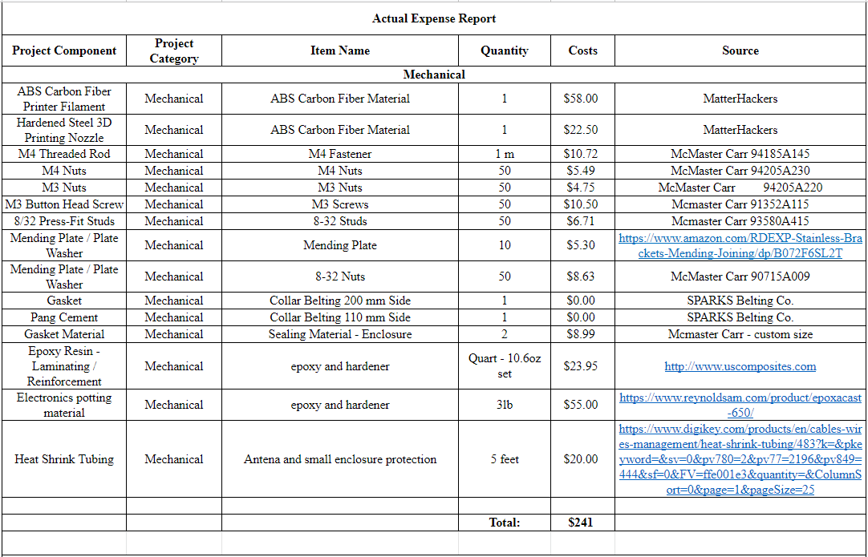

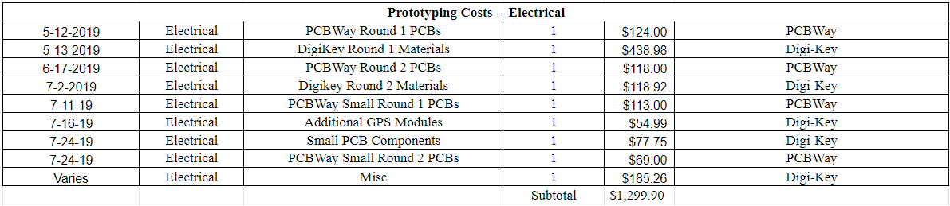

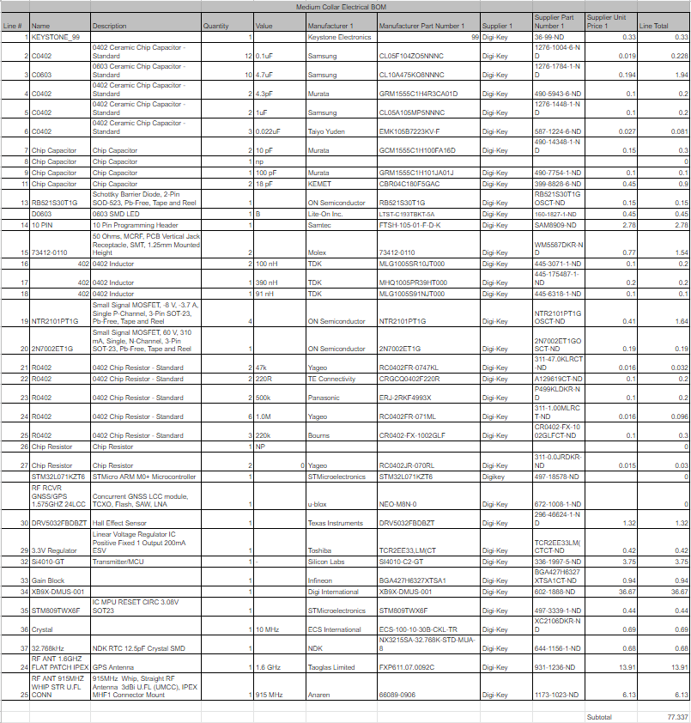

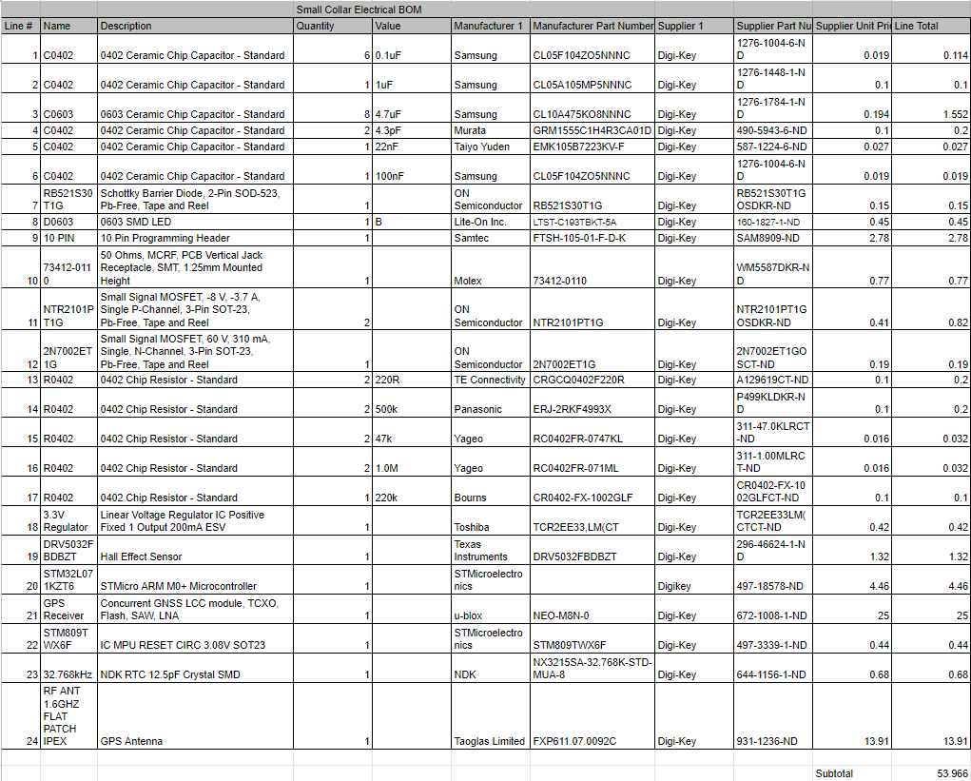

**Table 12.** Production Costs for Medium Collar

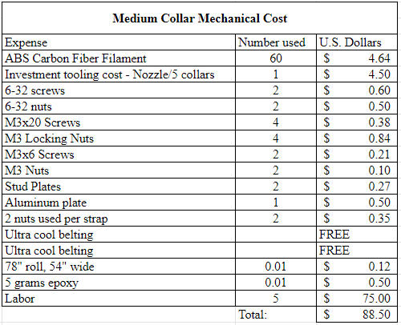

**Table 13.** Estimated Production Costs for Small Collar

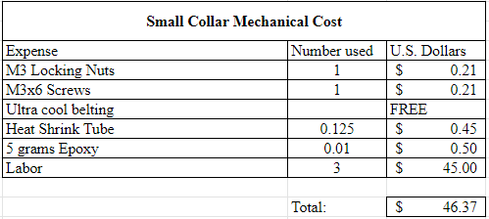

# 11 Future Project Suggestions/Recommendations

# 

This section highlights the recommendations for the next iteration of this project, as well as suggestions for where the team’s device can be improved.

**Mechanical:**

1. Print using different materials. ABS was chosen for superior water resistance, weight and strength. Other materials with similar properties like carbon fiber filled PETG would provide superior UV resistance. Polycarbonate would be superior to even PETG , but none of the printers we had access to could print at those temperatures.
2. 3D printing can be time consuming to get right, but testing and calibration of the machine you are using is essential for reliable prints. Printing on rafts is recommended. It may seem like a waste of filament, but a thin raft will save time and frustration later.
3. FEA was not done to determine the best infill pattern. A 100% infill was used. Dynamic infills could be used to create a much lighter design with similar strength.
4. The belting material is difficult to dye the proper color. Several dyes were tried but were not wholly successful. Getting custom colored belting from sparks would be the best option, even if it was pricey.
5. Customization is something that would be nice in future iterations. This design does not allow the based to be swapped, there were more ergonomic iterations that could have been implemented. With some redesign this could be done. This would allow for better fit and comfort for the animal.
6. If using the same concept for the enclosure, gasket, and strap stack up, thread the wires for the antennas first. Order antennas without the pads soldered to the u.fl connectors to save time and effort.
7. The strap design is robust, but a thinner strap would be a nice option for some animals. With little modification the stud plate could be reduced to use one fastener. This would result in a lower strength rating, but for some small animals this will be worth the weight savings.

**Functional/Electrical:**

1. Increasing the lifespan of the device and cautiously monitoring current draw.
2. External Flash Module added to circuit board for added storage for data.
3. Micro USB connection to the board or programming adaptor.
4. Less sophisticated GPS module on the board, using the same family would be sufficient but simplifying the use would be very beneficial.

# Appendix A -- Electrical Schematics

# 

# 

# 

# 

# 

# 

# Appendix B -- Electrical Simulations



**Figure B1.** Simulation Schematic for Power Selection Circuit

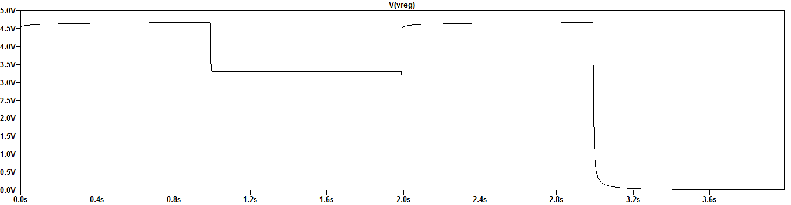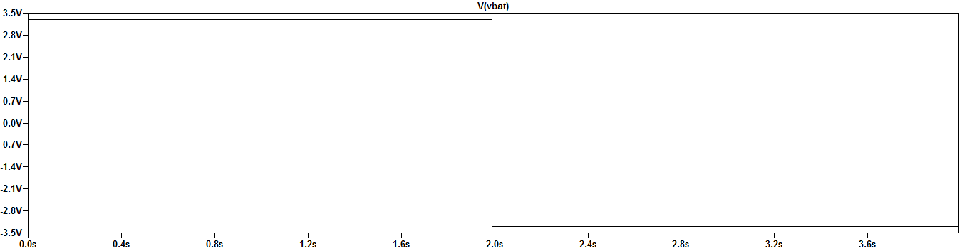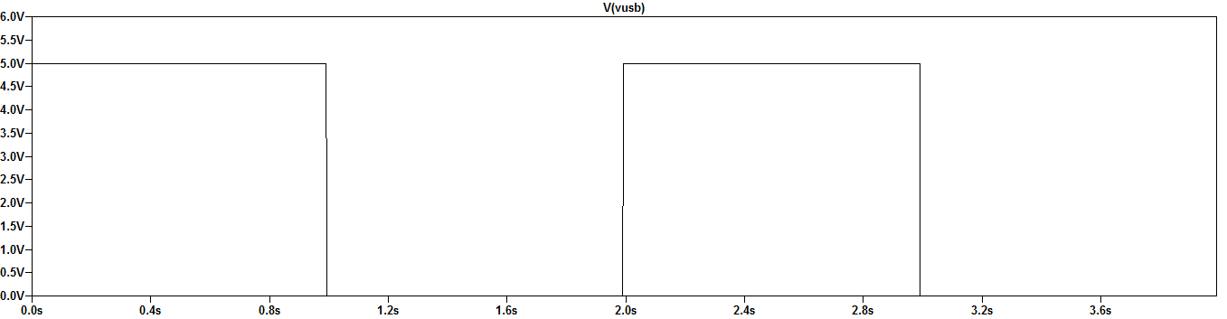

**Figure B2.** Simulation Output for Power Selection Circuit

The power input circuit was simulated in four states, battery forward voltage with and without USB power, and battery reverse voltage with and without USB power applied respectively. It can be seen that the circuit operates as expected in all four conditions allowing for power selection as well as reverse voltage protection.

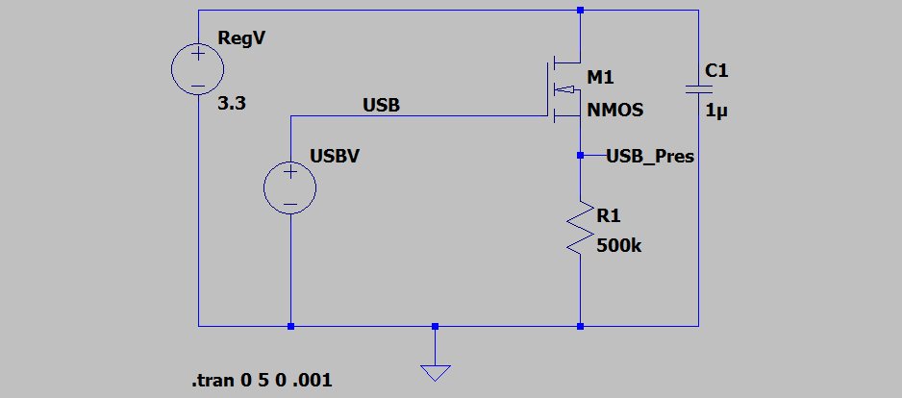

**Figure B3.** Simulation Schematic for USB Present Circuit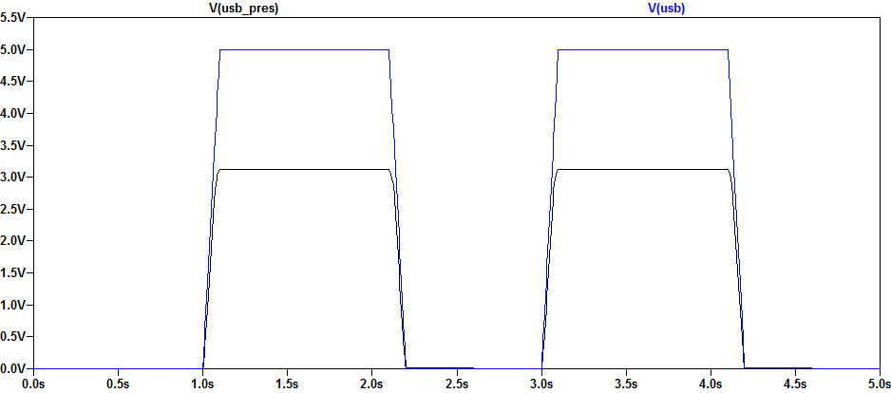

**Figure B4.** Simulation Output for USB Present Circuit

The USB present line follows the USB signal as expected.

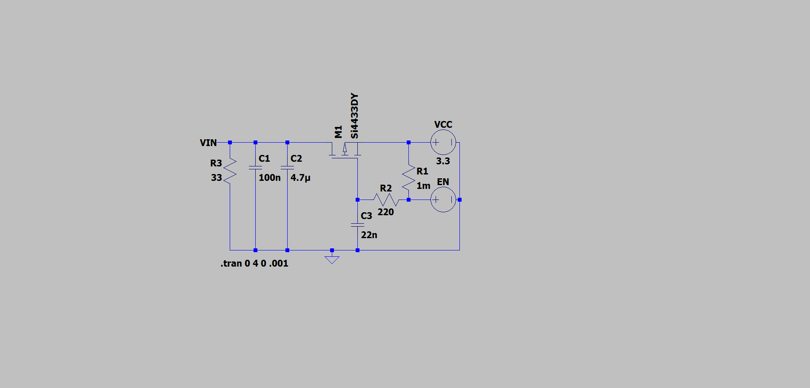

**Figure B5. S**imulation Schematic for Module Enable Circuit

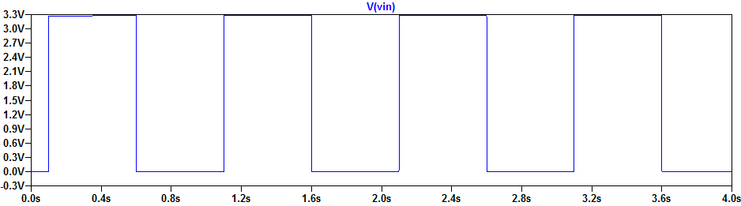

**Figure B6.** Simulation Output for Module Enable Circuit

The Vin line is shown to be controllable via the EN line as expected.

# Appendix C -- Mechanical Drawings (Also see attached PDF)

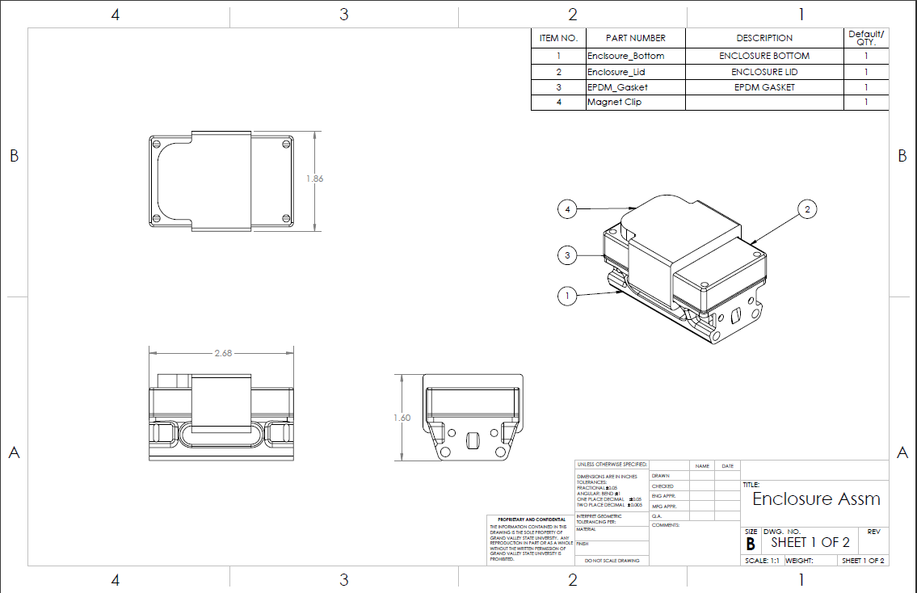

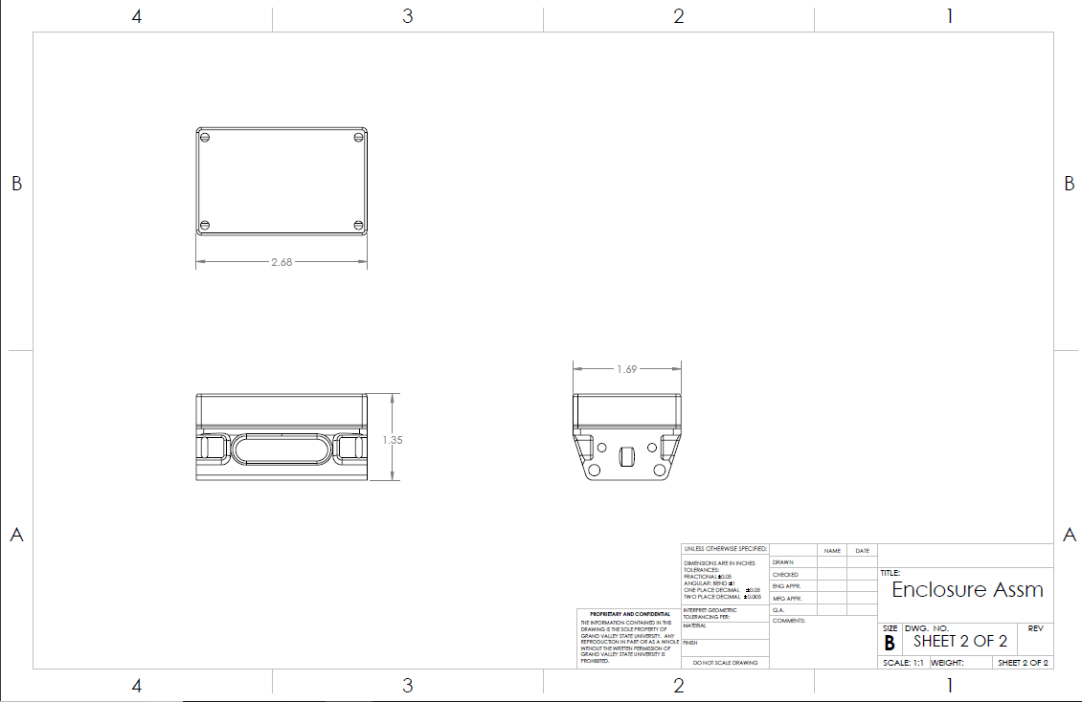

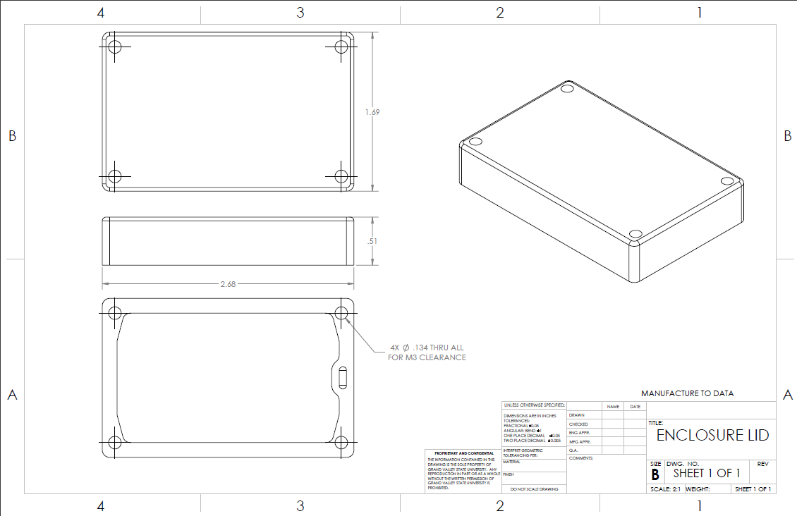

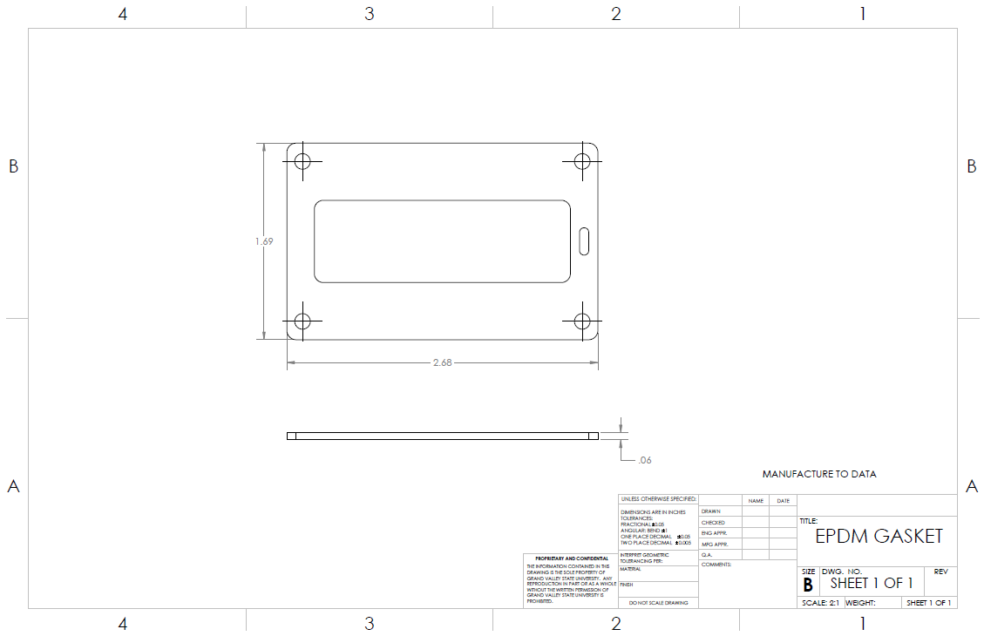

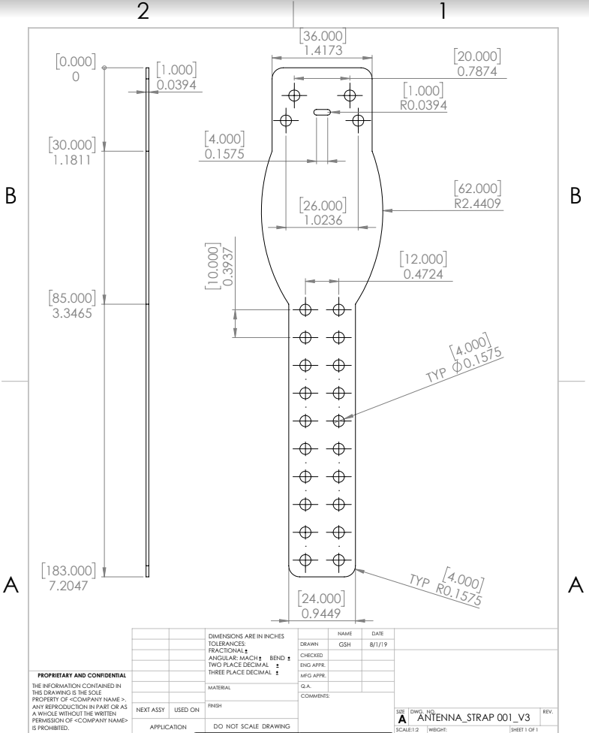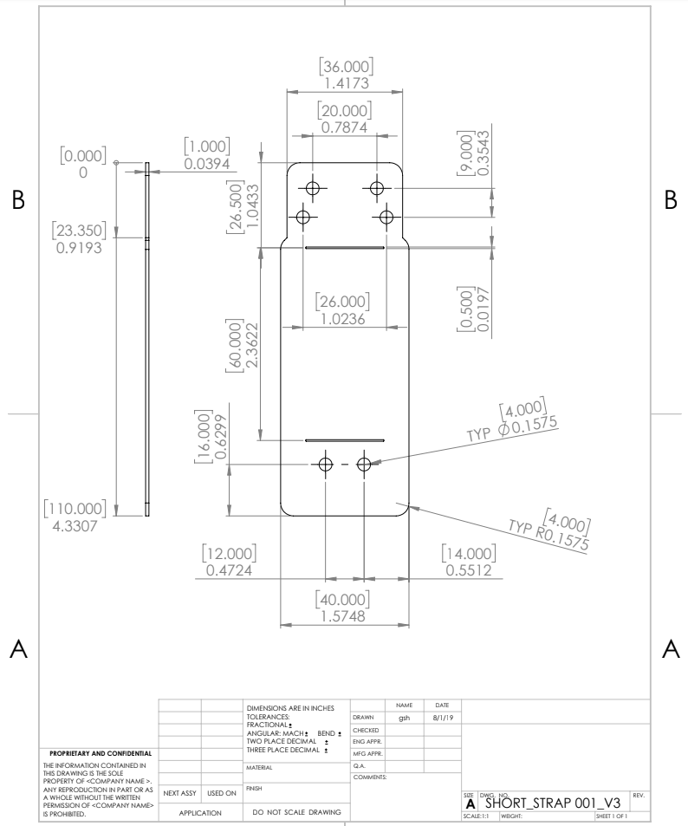

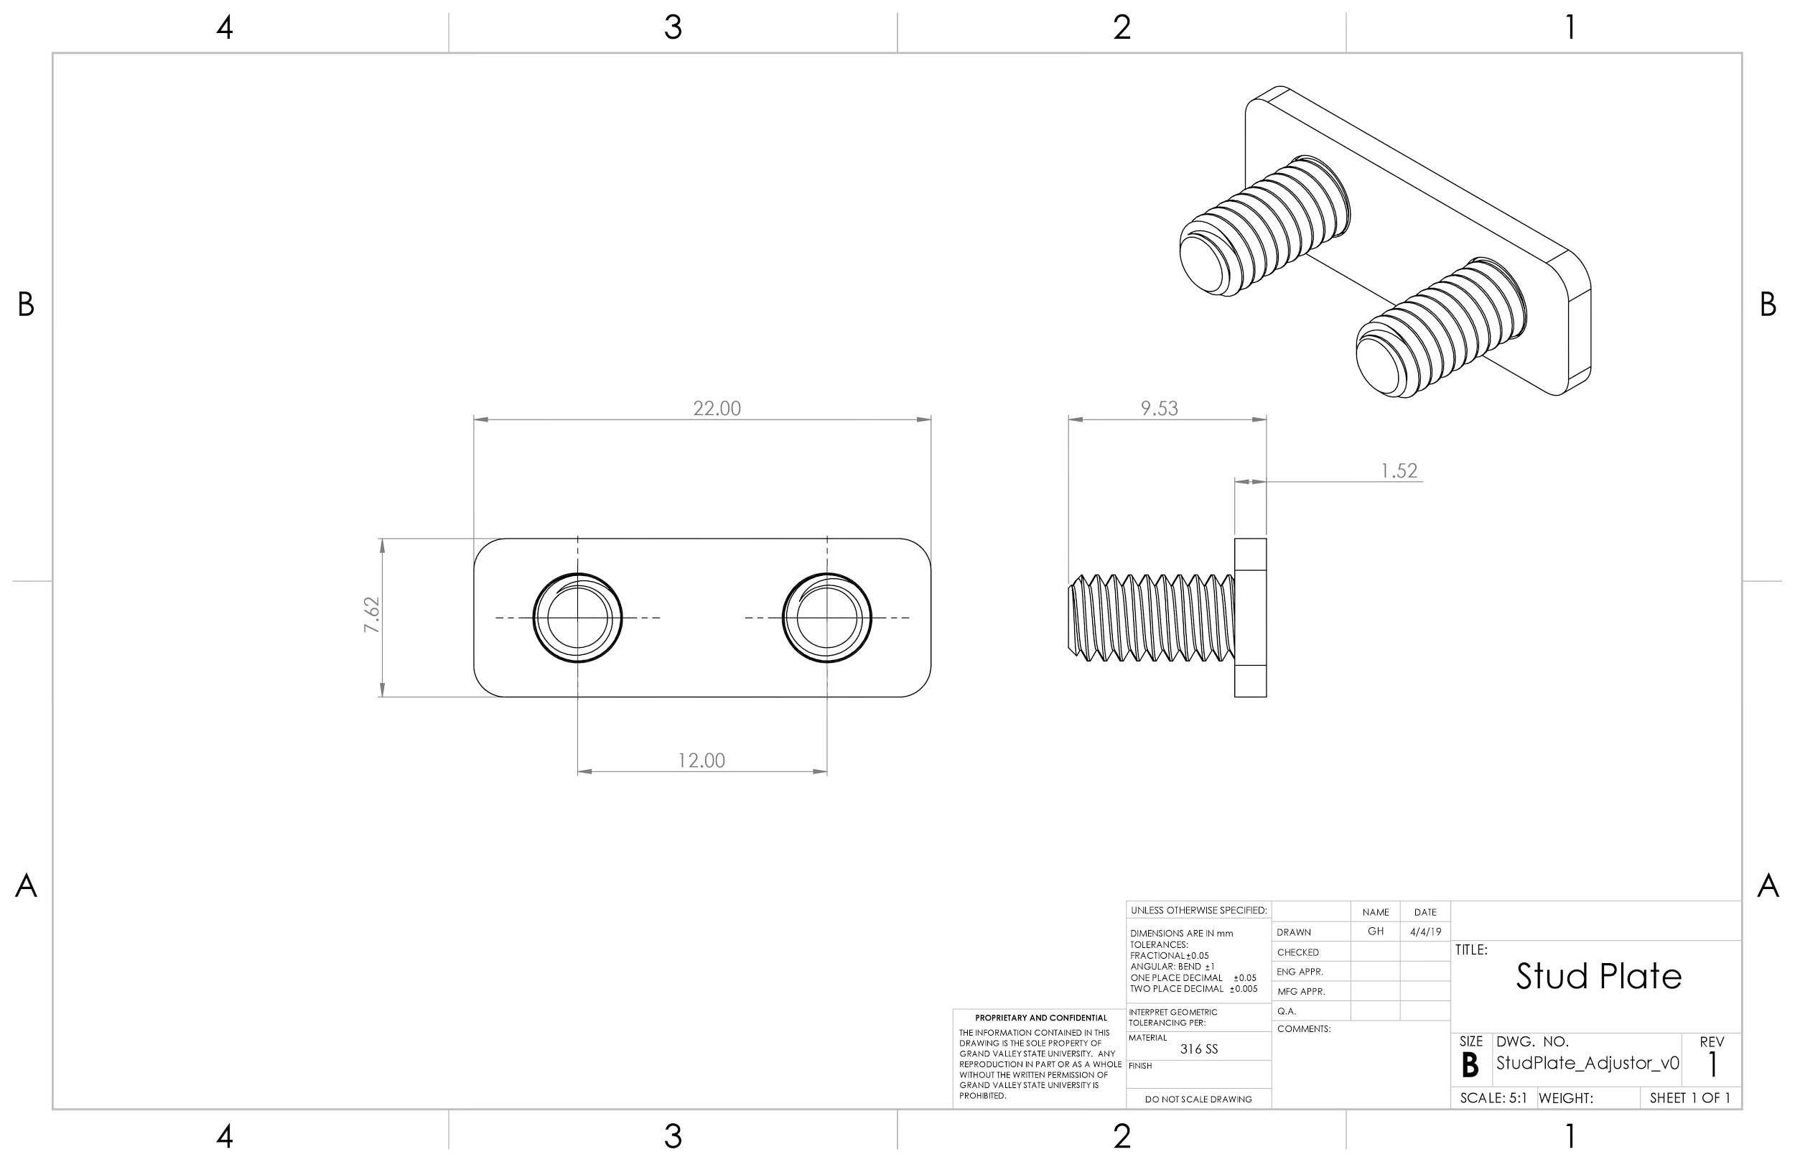

# Appendix D -- Verification Hand Calculations

**Battery Life**

Calculations were made assuming 6 GPS fixes per day with a VHF on-time of 4 hours once a week.

Medium Collar: Tadiran TL-5903 (2400mAh)

Small Collar: Tadiran TL-5902 (1200mAh)

**Table D1.** Best Case Battery Life Conditions (Medium collar)

|  |  |  |  |  |  |
| --- | --- | --- | --- | --- | --- |
| **Component** | **Mode** | **Current (mA)** | **Time (h/day)** | **Consumption (mAh/day)** |  |
| MCU |  |  |  |  |  |
|  | Active | 0.245 | 1.00 | 0.245 |  |
|  | Sleep | 0.00034 | 23.00 | 0.0078 |  |
| GPS |  |  |  |  |  |
|  | Acquisition | 25 | 0.0033 | 0.0833 |  |
|  | Tracking | 12 | 0.0008 | 0.01 |  |
|  | Backup | 0.015 | 24.00 | 0.36 |  |
| VHF |  |  |  |  |  |
|  | Active | 0.193 | 0.57 | 0.1102 |  |
| Xbee |  |  |  |  |  |
|  | Active | 35 | 0.0667 | 2.3333 |  |
|  |  |  | Total: | 3.1497 |  |
|  |  |  |  |  |  |
|  |  |  |  | 761.95 | Days to run |

**Table D2.** Worst Case Battery Life Conditions (Medium Collar)

|  |  |  |  |  |  |
| --- | --- | --- | --- | --- | --- |
| **Component** | **Mode** | **Current (mA)** | **Time (h/day)** | **Consumption (mAh/day)** |  |
| MCU |  |  |  |  |  |
|  | Active | 0.29 | 1.00 | 0.29 |  |
|  | Sleep | 0.00099 | 23.00 | 0.022 |  |
| GPS |  |  |  |  |  |
|  | Acquisition | 67 | 0.048 | 3.23 |  |
|  | Tracking | 67 | 0.0008 | 0.055 |  |
|  | Backup | 0.015 | 24.00 | 0.36 |  |
| VHF |  |  |  |  |  |
|  | Active | 0.193 | 0.5714 | 0.1102 |  |
| Xbee |  |  |  |  |  |
|  | Active | 55 | 0.0667 | 3.666 |  |
|  |  |  | Total: | 7.743 |  |
|  |  |  |  |  |  |
|  |  |  |  | 309.9217958 | Days to run |

**Table D3.** Best Case Battery Life Conditions (Small Collar)

|  |  |  |  |  |  |
| --- | --- | --- | --- | --- | --- |
| **Component** | **Mode** | **Current (mA)** | **Time (h/day)** | **Consumption (mAh/day)** |  |
| MCU |  |  |  |  |  |
|  | Active | 0.245 | 1.00 | 0.245 |  |
|  | Sleep | 0.00034 | 23.00 | 0.0078 |  |
| GPS |  |  |  |  |  |
|  | Acquisition | 25 | 0.0033 | 0.083 |  |
|  | Tracking | 12 | 0.0008 | 0.01 |  |
|  | Backup | 0.015 | 24.00 | 0.36 |  |
|  |  |  | Total: | 0.70 |  |
|  |  |  |  |  |  |
|  |  |  |  | 1699.347639 | Days to run |

**Table D4.** Worst Case Battery Life Conditions (Small Collar)

|  |  |  |  |  |  |
| --- | --- | --- | --- | --- | --- |
| **Component** | **Mode** | **Current (mA)** | **Time (h/day)** | **Consumption (mAh/day)** |  |
| MCU |  |  |  |  |  |
|  | Active | 0.29 | 1.00 | 0.29 |  |
|  | Sleep | 0.00099 | 23.00 | 0.022 |  |
| GPS |  |  |  |  |  |
|  | Acquisition | 67 | 0.048 | 3.238 |  |
|  | Tracking | 67 | 0.0008 | 0.0558 |  |
|  | Backup | 0.015 | 24.00 | 0.36 |  |
|  |  |  | Total: | 3.966 |  |
|  |  |  |  |  |  |
|  |  |  |  | 302.500418 | Days to run |

## 

## 

**Enclosure Strength**

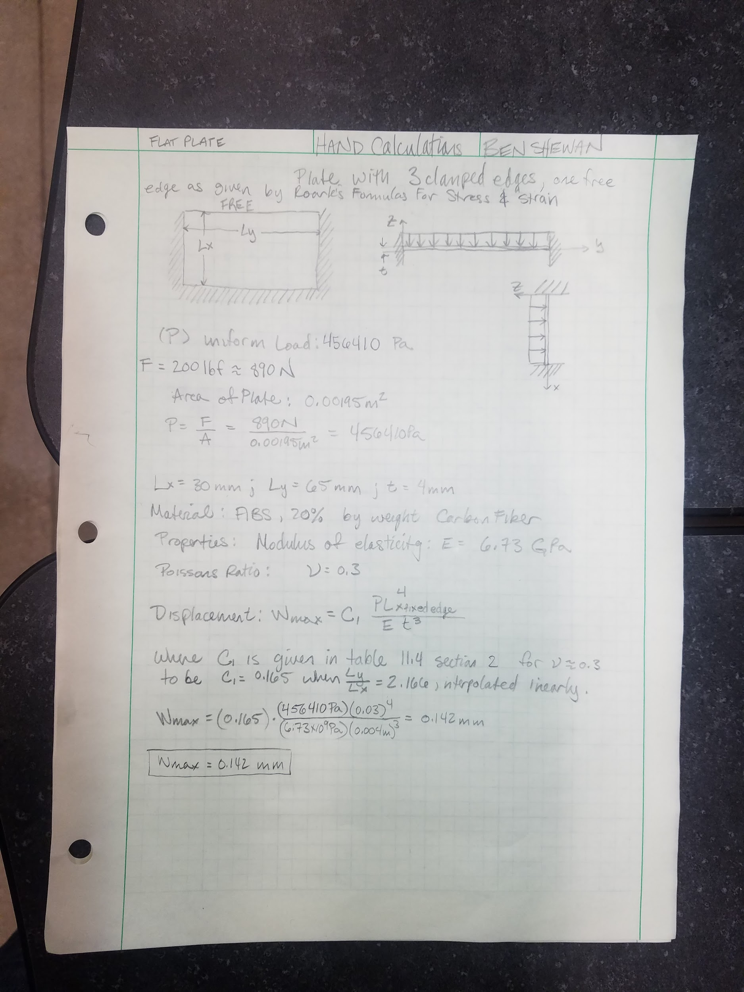

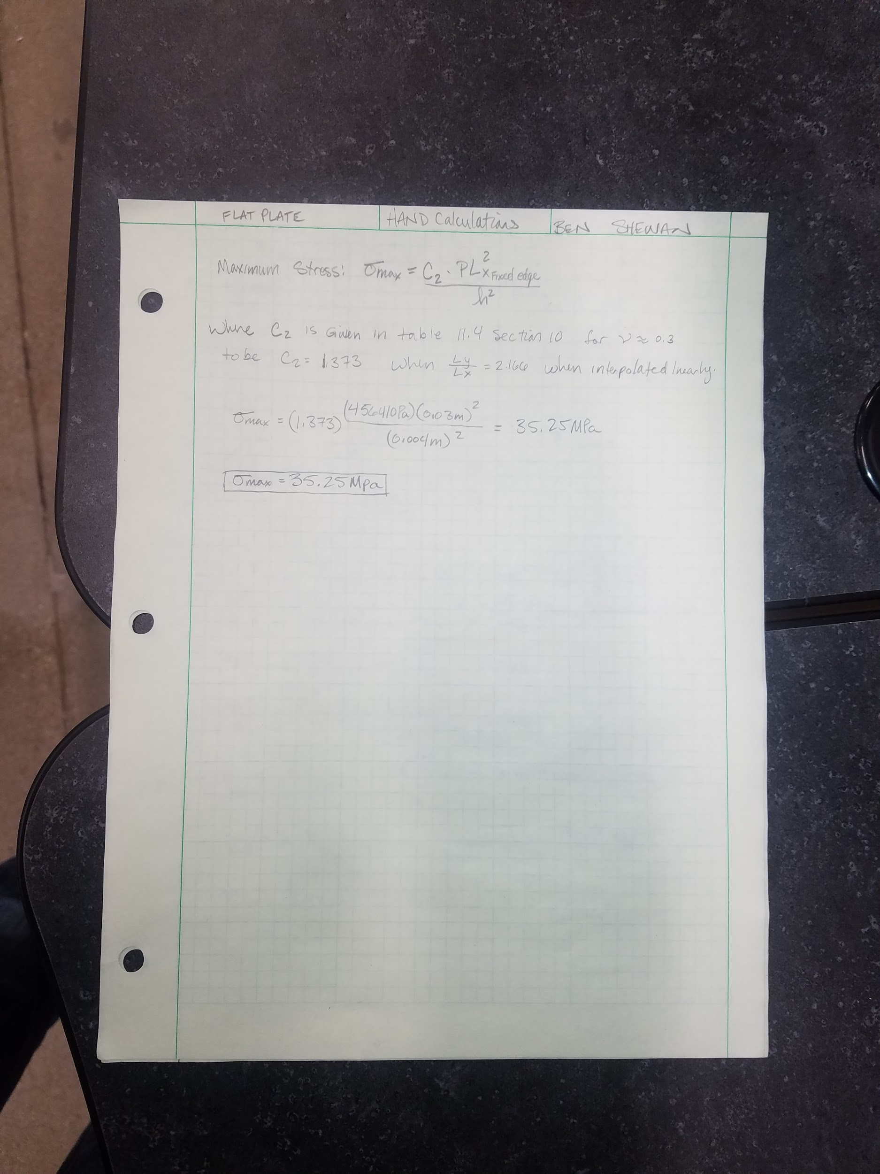

**Collar Belting Strength**

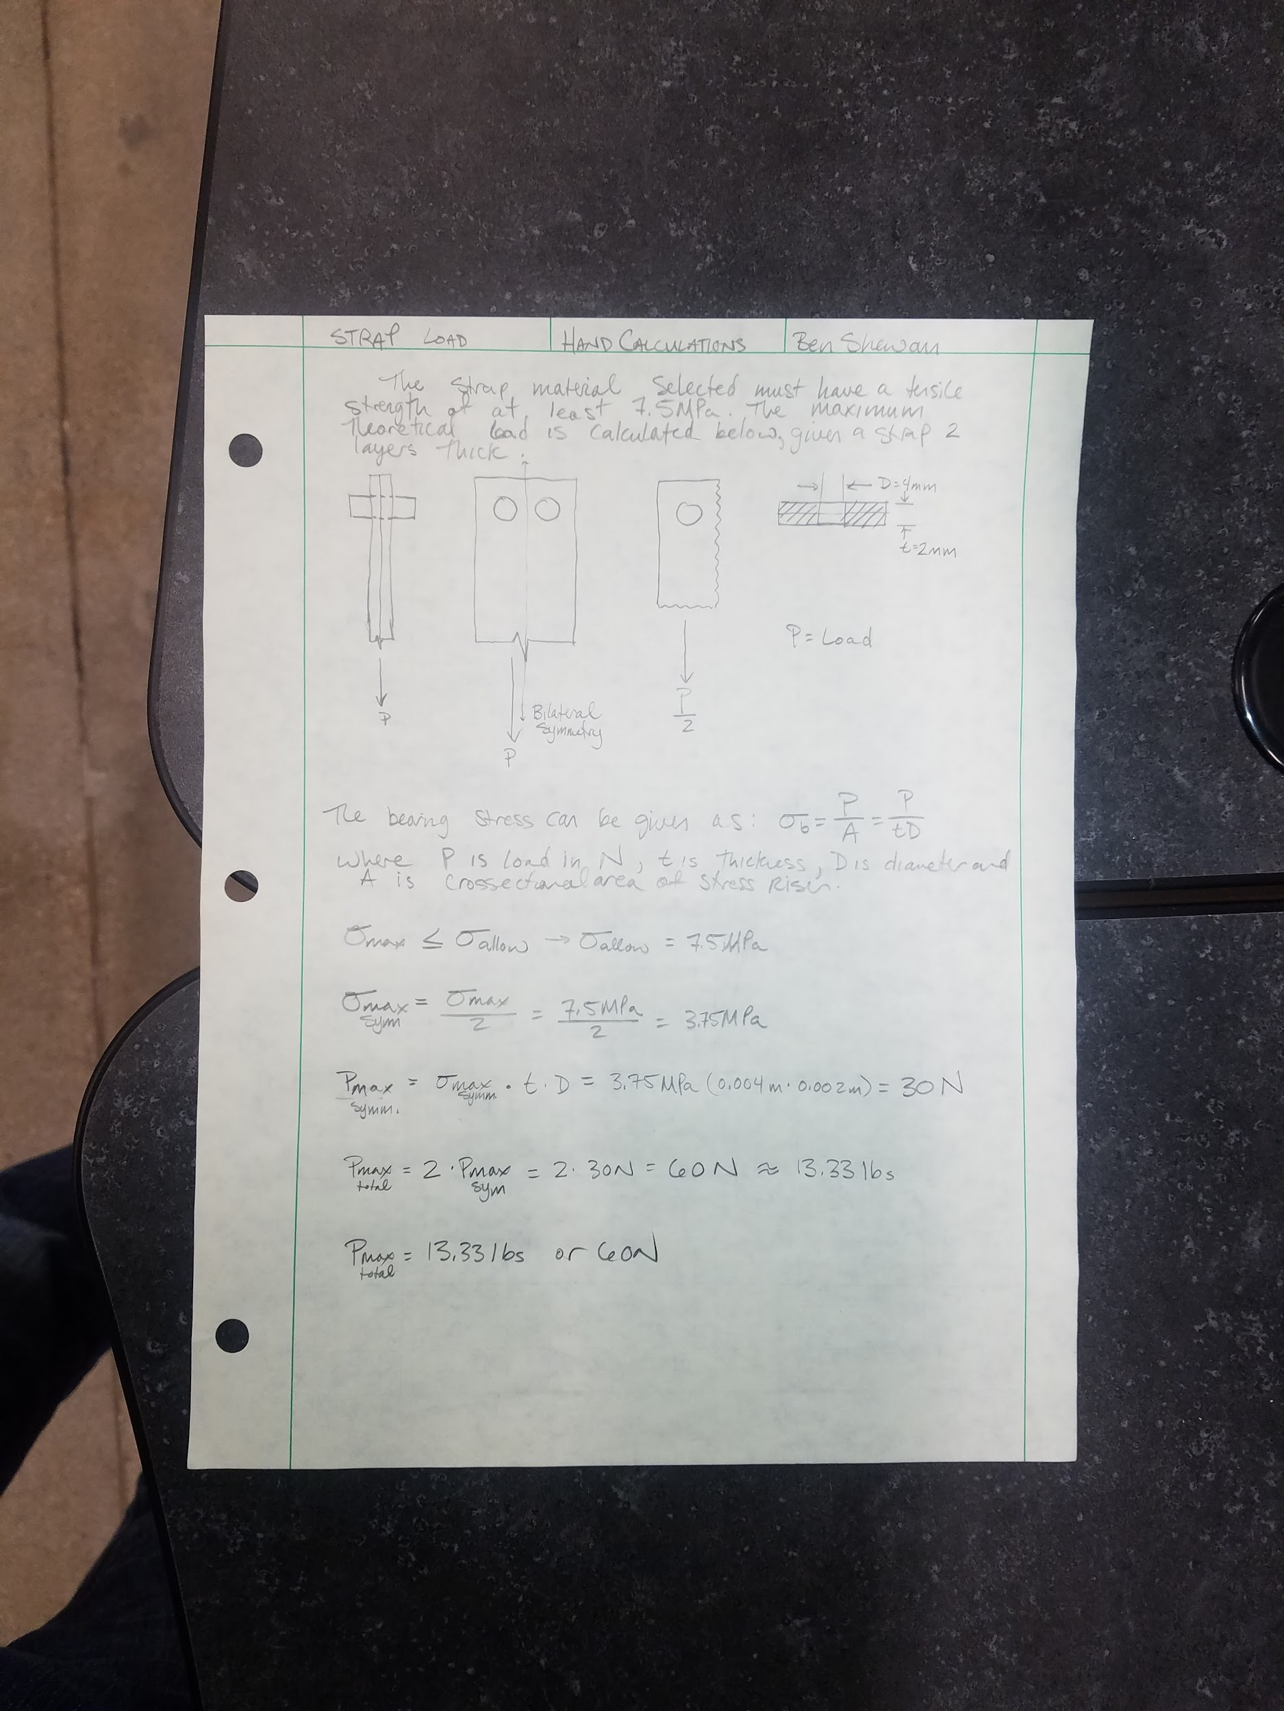

This document signifies that Benjamin Lawson, Benjamin Shewan, Collin Halamka, Collin Maker, and Garrett Harris have completed the design portion requirements of the Wildlife GPS Tracking Collar senior design project. By signing this document, it is acknowledged that the team is not responsible for any further changes to the project other than the changes listed below. If sign-off conditions are listed below, the group has received conditional sign-off and has completed the design of the senior design project upon the completion of the listed conditions.

Sign-off Conditions:

_______________________________________________________________________

_______________________________________________________________________

_______________________________________________________________________

_______________________________________________________________________

_______________________________________________________________________

_______________________________________________________________________

_______________________________________________________________________

_______________________________________________________________________

_______________________________________________________________________

**Sponsors: Signature Date**

Dr. Paul Keenlance ________________________________________________

Dr. Jeffrey Ward ________________________________________________